Continuous human occupation since 45 ka at Zhaoguodong, southwest China: Implications for modern human dispersal in East Asia

**Abstract:** Since marine isotope stage 3 (MIS3), major alternations in global climate, population, and human behavioural patterns have taken place in many regions of the world. In China, ambiguity in modern human evolutionary trajectories, variation in lithic industries, and poorly studied archaeological locations confound our understanding of Upper Palaeolithic demography and technology in East Asia. To address this issue, we present a complete and continuous profile with a relatively monotonous lithic industry spanning from the start of the Upper Palaeolithic to the Neolithic period in southern China. The assemblage is characterized by small flakes and tools simply delaminated from black chert. And they are associated with finely made bone tools and the use of fire. Our study shows that behavioural patterns, including lithic production, organic tools, and pyrotechnologies at Zhaoguodong cave had not been interrupted or altered significantly over the past 45 thousand years, which may also suggest a relative consistency in human groups. And this technocomplex broadly parallels with contemporary assemblages found in South Asia and Southeast Asia, suggesting a similar behavioural patterns of their makers.

**Keywords:** Southwest China, Upper Palaeolithic, Neolithic, modern human, lithic industry

# 1 Introduction

Current research including genetic, and archaeological material suggests that anatomically modern humans (AMHs) from Africa dispersed into Southeast Asia around 65-45 ka (Demeter et al., 2017; Westaway et al., 2017). Likewise, both genetic and fossil data support the entry of AMHs around MIS 3 across modern day China (Li et al., 2018; Li et al., 2010; Shang et al., 2007; Yang et al., 2017; Zhang et al., 2022; Zhang et al., 2004). Subsequent migrations, including one after 40-30 ka within Eurasia (Gutenkunst et al., 2009; Rasmussen et al., 2011), and several associated with the Neolithic period (Curnoe et al., 2015; Kong et al., 2011; McColl et al., 2018; Zhong et al., 2011) occurred within East Asia. These multiple migrations raise several possibilities for dispersal and migration routes and distinct technological adaptations. For example, early dispersals of AMH via a northern or inland route (Zwyns et al. 2019) or a southern route (Curnoe et al. 2016). However, in terms of technological perspective, little archaeological evidence from early Late Pleistocene (40-30 ka) in south China have been found to support the ‘southern route’ dispersal model (Jiang, 2006; Mao and Cao, 2012; Zhou et al., 2019). In this paper we report on excavations at Zhaoguodong cave, Guizhou Province, in Southwest China as a contribution to understanding the nature of human activity on the southern route.

The appearance of *H. sapiens* in East Asia, documented in available paleoanthropological and archaeological records, reveals that they were present in northern Asia at least 40,000 years ago (Hu et al., 2009; Li et al., 2013; Yang et al., 2017), while human activities in southern China are more complicated where fossils assigned to *H. sapiens* have been successively found within a larger time span and with morphological variances, in addition to other unknown species. Such intricacy is also reflected by complex cultural trajectories in southern China during the Upper Palaeolithic period (Bar-Yosef and Wang, 2012). Compared with the frequent discoveries of blade and microlithic industries, personal ornamentation, the symbolic use of ochre in northern China (Li et al., 2018; Yang et al., 2017), the archaeological evidence in the south is typified by flake tools that seem to exhibit few alternations and developments from proceeding technological packages (Qu et al., 2013).

Recent studies on ancient human DNA reveal complicated populational fusion in Southeast Asia and southern China post-Young Dryas (Lipson et al., 2018; McColl et al., 2018; Wang et al., 2021; Yang et al., 2020). Demographic patterns since Marine Isotope Stage 3 (MIS 3) are still obscure. In this study, we present a site that provides an exceptional opportunity to explore the undisturbed development from the Late Pleistocene to the Neolithic period. The sedimentary process of the site - Zhaoguodong cave - occurred continuously from 45k to 7k BP, with no significant identifiable interruptions in terms of chronology and cultural behaviours. Regarding the crucial period of the site’s occupation, it has the potential to serve as a proxy to attest whether modern humans were present in southern China around MIS 3 and how they subsisted. It may also provide a regional case for a delayed transition from the Palaeolithic to the Neolithic period in subtropical East Asia.

# 1.1 Geographic background and excavation

Zhaoguodong Cave (N26°32′22.83″, E106°27′00.02″, 1,280 m a.s.l.), 20 m wide and 25 m in length, is located in Yankong village, Guizhou Province, in Southwest China (Figure 1). Modern Guizhou has a humid subtropical monsoon climate. The temperature fluctuates subtlety with an average annual temperature in most areas of the province of about 15 ℃. The average temperature of the coldest month (January) is usually 3-6 ℃, higher than other areas of a similar latitude. The average temperature of the hottest month (July) is generally 22-25 ℃. This area is humid, most parts of the territory generally experience more than 150 cloudy days with an annual relative humidity of above 70%. Weather extremes, including droughts, high wind, freezing temperatures, and hail, frequently occur, contribute to the warm and humid climate, and determine the local landscape.

The topography of Guizhou along with neighbouring areas is characterised by a wide distribution of karst. This type of landscape is formed when carbonate rock, such as limestone, is weathered by underground drainage systems and surface water. Zhaoguodong was developed in such limestone mountains. In the middle of these mountains, there is an extended north-south basin formed by the Maxian River, which is 300 m from the cave and 30 m lower. The mountain’s carbonate rocks were formed in the Middle Carboniferous Huanglong Group with a major component of sparry limestone and coarse-grained dolomite. When they were buried in sediment, the water flowing from both underground and ground seepage dissolved the rocks and gradually formed the main chamber of the cave until till the downward flow of the groundwater (the Maxian River), and the mountain’s elevation stopped the cave’s horizontal extension. Today, except for temporary sheet flow concentrated along fractures and roof of the cave, the cave has basically dried up, with secondary calcium carbonate precipitates forming stalagmites at the end of the chamber. The cave is situated to the west of the basin, with an entrance facing east.

# 2 Excavation history and methods

The cave was discovered in March 2016 during an archaeological survey led by the Guizhou Institute of Cultural Relics and Archaeology, Sichuan University, and the Chengdu Institute of Cultural Relics and Archaeology. A trench with an approximate area of 70 m2 by 8 m deep was unearthed near the entrance over five excavation seasons. In April 2016, two 1×1 test pits were excavated with cultural deposits 5.65 m thick, which had not yet been unearthed due to natural accumulation. Formal excavations were carried out in 2017, and covered a total area of 27 m2 to a depth of 1.5–2 m, with a large amount of gravel exposed at the surface. For the 2018 excavation, to clarify the distribution of the gravel, we laid out a 3×3 m2 trench in the north-western corner of the previous year's excavation, and excavated it to the same level as the previous year. In 2019 and 2020, we excavated the area near the entrance of the cave down to the bedrock. Research on recovered remains from 2016-2019 is still ongoing. In this paper we focus only on the materials unearthed during the 2020 excavation, where the most complete archaeological sequence of the cave was unravelled (Figure 2).

All the excavation areas were explored following a standard procedure as follows. The excavation area was framed by a 1 m2 grid pit. Each pit was dug horizontally by 5 cm at a time within an intact natural layer. Recognizable mammal bones, artefacts, and hearths were documented within their original context on the current working surface. The corresponding sediment was collected for flotation using a 0.2 mm screen to catch the light fraction and a 1 cm screen to catch the heavy fraction. After all the individual pits reached the same level, photographs were taken and a 3D model was created using PhotoScan. Context information, including the layers, attribution (e.g. stone artefact, bone, pottery sherds, and carbonate), and three-dimensional coordinates, were recorded by a total station Leica TS02 equipped with newplot 2.0 which simultaneously generated an identification barcode (Figure 3).

# 3 Results

# 3.1 Stratigraphy

A complex depositional process was observed in the cave. On the one hand, dolines and underdrains developed all along the sedimentation, leading to a collapse eastward the centre of the cave and a tensile fracture of the strata. The gravitational imbalance generated horizonal variations. Changes in the vertical strata were also noticeable. However, their colour, texture, and inclusions were largely affected by human occupation, such as the use of fire, rather than mechanical alteration. Given the complicated sedimentary process, a universal lithostratigraphy for all the sections was impractical. Thus, we use the south wall’s pits N46E47—N46E50 to represent the stratigraphical profile of the cave. Except for the doline-caused subsidence and sporadic animal burrows, the lithostratigraphic units were successive, and not disturbed by major erosion or significant disturbances. Fireplaces were identified where ash, charcoal grains, and burnt materials appeared in high concentrations, without necessarily exhibiting a formal hearth structure. Edges of most stone artifacts are fresh and sharp showing little or no traces of post-depositional process or hydraulic impact. Stone artifacts with heavy abrasion only account for small proportion (0.2%), indicating most artifacts were buried quickly without long-distance transport by natural process. According to experimental flaking studies, ratio of small, detached pieces against the assemblage is an important proxies for site integrity (de la Torre et al., 2018; Kuman, 2003; Petraglia and Potts, 1994). The ratio between cores and small flaking debris here is extremely low (2.98%), confirming the minimal impact from water disturbance or geologic process. A low degree of size sorting of archaeological material further indicates minimal disturbance; Figure 3d shows artifacts and bones of different sizes present in the same lamina of a layer. A total of 25 sedimentary units were identified, primarily based on lithological changes (Figure 4).

**3.2 Radiocarbon ages**

A total of 13 14C AMS dates were obtained from the profiles reported here to provide a chronological framework for the site (Table 1, Figure 4, Figure 5). Most of the samples were bone fragments collected during the excavation and charcoals recovered from hearths. In this area of the site the radiometric age sequence for the profile was consistent with field observations and useful for constraining the ages of the three archaeological levels. The lowest sample was charcoal taken from HT51, yielding an age of 44,881-43086 cal. BP, close to the limit of radiocarbon dating, and thus possibly an underestimate of the true age. This sample represented the onset of sedimentation and provides an age for the earliest record of human activity in the cave.

# 3.3 The Late Pleistocene assemblage

The Late Pleistocene sequence at Zhaoguodong consists of a 3 m thick sedimentary series in which three lithological phases are evident. The lower part (phase 1) contained few artefacts, bones, and fireplaces. The middle part (phase 2) was analogous with the lowest part, except for the increase in the number of artefacts and ash laminas. The yellow sandy clay of phase 1 and 2 was truncated by the third section (phase 3), the top part of the Late Pleistocene series, with thin layers with interbedding of white-grey ash, black charcoal, and dark brown sandy clay. A total of 1,783 stone artefacts composed of various knapping elements were recovered, namely, cores, flakes, retouched tools, and abundant debitage (Table 2), alongside other lithic materials associated with human activities, such as burnt stones and minerals that may have been used for pigment (Figure 6).

### 3.3.1 Phase 1

This phase lies on top of the bedrock, and contains three fireplaces and five sedimentary units. Most of the stone artefacts and charred bone as well as bone tools (n= 3, osseous awl) were recovered from the fireplaces. Burnt rocks and charred bones were found small quantities confirming the use of fire when hominins first arrived at the cave. The overall low density of archaeological materials in phase 1 implies this spot was not preferred for intensive occupation and only used occasionally over time. Black chert is the main raw material, with a small amount of grey chert (Figure 7). The stone artefacts are generally smaller than 50 mm. Debris and chunks dominate the assemblage (Figure 6). According to the core configurations, unidirectional percussion without preparation appeared to be the only knapping strategy when producing flakes (Figure 8-1). The reduction sequence was short, with one or two series that yielded a few successful debitages, leading to various morphologies. Knapping was usually disturbed by the heterogeneous texture of the chert. Complete flakes, most of which are side flakes (width > length), display similar patterns as the cores, such as few dorsal scars (n= 2-6) and unprepared platforms (Figure 8-2,3; SOM Figure S82-S87, S89, S91-93). Cortex is uncommon and initial flakes with full cortical dorsal are missing, indicating off-site initial reduction. Scrapers are the most frequently retouched tools made from flakes (complete or incomplete) and chunks (Figure 8-4; SOM Figure S88, S90, S93). Isolated points are also evident. The retouching is restrained and informal, usually only on one edge. Interestingly, the retouched tools are generally larger than the unretouched flakes and cores (Figure 9). It is likely that such flakes were produced outside the cave or deliberately selected from larger flakes for tool manufacture.

### 3.3.2 Phase 2

This phase is 2 m thick and composed of five units, seven fireplaces and a substantially greater density of artefacts than phase 1. Petrographic characteristics include yellow coarse-grained silt embedded with large fallen rocks. More than 400 stone artefacts, including all the elements of the reduction sequence (Figure 6), were recovered (though mostly debris and chunks) associated with the countless bone fragments and burnt materials and a total of four osseous awls. Although raw materials are still dominated by black chert, the diversity of raw material increased to seven types of rock (Figure 7). Unidirectional, bidirectional and multidirectional strategies were utilised when knapping cores (Figure 10f, SOM Figure S79, S80). A distinct gap is found in the dimensions of the cores, which may imply functional diversity. While the proportion of cortical and fracture platforms decrease, the proportion of plain platforms increase, as did the number of reduction series. While the cores were made only of chert, the raw materials of the flakes included a few exotic types such as opal and crystal quartz. Flake platforms are predominated by plain platforms, according with schemes observed on cores (Figure 10-a, b; SOM Figure S65, S69, S74-S76, S78, S81). The flakes show some morphological variation and side flakes are also on the oriented products. Dorsal scar patterns are more complicated and show on average four scars. Only one primary flake was found. Given that cores were made from two different size cluster and all flakes are less than 40 mm, there seems to be a net export or depletion of larger flakes after production. Unlike cores and flakes, retouched tools are merely black chert and 75% are transferred from broken flakes and chunks. The retouching approach is still simply working on one edge, and the most favourite tool type remains scrapers, although other tools, such as denticulates and notches also occur (Figure 10-c, d, e; SOM Figure S66, S70, S73, S77).

While other techniques are slightly altered, one important shift that makes phase 2 distinct is the appearance of exotic raw materials (Figure 7), which is likely due to an expansion of the cave users’ foraging range or trading activity. Considering the deletion of flakes obtained from larger cores and the incongruity between the raw materials of the cores and debitages, we hypothesise that the bulk of the products took place outside the cave, which means the cave typically saw sporadic, brief occupation. However, the increased number of hearths suggests a more frequent exploitation of the cave compared to phase 1. The lowest identifiable using of fire in phase 1 is evidenced on two abreast circles, one is probably a pigment residue and the other is fire use associated with few burnt materials. In contrast, fire usage in phase 2 is accompanied by charred bones and abundant charcoal. The fireplaces extend by 70 cm, with an accumulated depth of up to 65 cm. A high concentration of piles of angular gravels with a burnt black coating suggests an intentional construction of a fireplace and sustained fire use.

### 3.3.3 Phase 3

Phase 3 consists of six archaeological units. There are no sterile sediments separating phases 2 and 3, however, unlike the last two phases, the petrology of phase 3 changes dramatically from laminar yellow sandy silt to fine grey-brown horizontal cross bedding mixed with mass charcoal grains, burnt red particles, and strips of white dirt. The thickness is uneven, ranging from 20 to 120 mm. Phase 3 is marked by a substantial increase in the quantity of mammal bones and stone artefacts (n = 1,381). Siliceous rocks (black chert, colored black chert, grey chert, and stripe chert) are still the most common raw material, although sedimentary and metamorphic rocks of variable grain size were also identified (limestone, sandstone, quartzite, and opal, Figure 7). Multidirectional and bipolar percussion are present in the core reduction system for the first time in the sequence. The cores demonstrate a variety of morphologies (Figure 11-c, d; SOM Figure S60-S61, S63-S64). This may be because the diverse raw material required different skills to knap, and different knapping techniques and strategies generate amorphous outcomes. Most cores are small, with an average length of less than 5 cm.

There are 12 unidirectional cores out of 17 hard-hammer percussion cores. They are mostly made of chert, with one exception that is made of limestone. Unidirectional cores are smaller (mean length = 2.4 cm) and they are exploited barely exhibiting any preparation on the platform or working surfaces. The value of the mean platform angle decreases to 70°, approaching that of phase 1. Although successful removals are made, only one knapping series can be identified on almost all the unidirectional cores. Bidirectional and multidirectional cores display analogous patterns, non-preparation, and few reduction phases, but increasing platform angles (80°). Bipolar cores are mostly made from chert and are elongated, with an average size of 2.5 x 2.7 x 1.5 cm (SOM Figure S61).

Flakes were made on more varied raw materials, such as sandstone and quartzite, although black chert still represents more than 50%. Flakes show some morphological variation (Figure 11-b; SOM Figure S62), but most of have a width longer than their length. It seems cores from the whole Late Pleistocene level are aimed at obtaining small side flakes, mainly by means of simple production systems like unidirectional or bidirectional knapping. Cores were also abandoned after a short reduction process. This could be attributed to raw materials whose homogeneity is largely debased by internal fractures. Plain platforms are common (72.4%), without showing facetted preparation. Initial flakes were not found though there are a total of 87 completed flakes. The number of dorsal scars increased to an average of 4-5, and the patterns are also more diverse. Most of the flakes have a non-cortical dorsal surface and initial flakes are absent, suggesting a late stage of reduction.

A total of 18 retouched pieces were found in phase 3, most of which were achieved by the modification of chunks. Scrapers remained the main tool type (Figure 11-a, e), while denticulates and notches only represent a small proportion of the find. The average size of chunk tools, 2.8 x 3.5 x 3.1 cm, is parallel to the cores and flakes. The retouching strategy was to work on mostly one edge, 2-3 occasionally, with simple, separated, marginal scars left on the edge. Flake tools are somewhat larger than chunk tools, with a mean size of 3.7 x 2.9 x 1.1 cm and the retouching is more successive compared to the chunk tools. Another latent variation from earlier stages is the retouching approach transferred from ventral-dorsal, to alternation manners.

There were three fireplaces (HT40, 41, 42) that may belong to a major fire-use event or were used within a short period (Figure 12a). A thick layer of burnt red soil lying underneath and associated and aligned with a black and grey ash sub-circle, indicates that HT41 might have been the centre of this event. A combination of many bone fragments, various polishing bone tools (n = 31, Figure 12b-2), rocks, and burnt and stone artefacts were distributed within the fireplaces. Although the scale of this event, 80 x 60 cm, is not beyond earlier fireplaces, the dramatic changes in lithology, high density of fauna and artefacts, and recognisable fire structures suggest repeated, higher frequency use of fire during this stage, as well as a longer occupation of the cave.

# 3.4 Neolithic assemblages

The Neolithic period is often defined by the presence of polished stone and grinding tools, ceramics, and agriculture in the Holocene (Gibbs and Jordan, 2016; Weisdorf, 2005). Direct evidence of agriculture, such as rice and soybean, has been found in both northern and southern China (Cohen, 2011; Jones and Liu, 2009). However in Southwest China, the Neolithic period is characterized by a protracted series of developments other than incipient cultivation and agriculture (Chi and Hung, 2008; Zhang, 1998). Thus at Zhaoguodong we recognise the Neolithic deposits from the presence of pottery and ground stone artefacts. The Neolithic assemblages at Zhaoguodong are composed of two parts: Neolithic level and Neolithic surface unit. The Neolithic level consists of seven archaeological units. A striking increase in the density of stone artefacts and bones occurred during this stage. A total of 15,845 stone artefacts were found, more than 80% of which are chunks and debris (Table 2, Figure 6). Ground and polished stone tools are also found for the first time, although only a small amount. The most used technology remains hard hammer percussion skills with a growth of bipolar technique application. Bone with delicate manufacture techniques tools (n=151) were also more abundant during this period (Figure 12b-1,3). The use of fire in the Neolithic levels exhibits structural attributes that vary from those in the earlier phases. They appear to be more fixed and overlap each other, indicating alterations in pyrotechnology (Figure 3c). Pottery sherds were also found associated with stone artefacts and bones; however, most pieces are heavily weathered fragments.

A large variety of raw materials – up to 10 categories – were identified for knapping stones, including chert with different tones, quartzite, limestone, opal, chalcedony, and crystal quartz (Figure 7). As in the underlying sequence, chert is still the predominant raw material. More than 70% of the cores were reduced by hard-hammer percussion and about 27% are bipolar cores (Figure 13-g; SOM Figure S21, S40, S50). Regardless of the techniques used, the overall dimensions remain small. Subtle discrepancy can still be found among the different raw materials: for instance, the cores made of chert are usually smaller than those made of limestone. Another latent impactor of size may come from technique. Bipolar cores are slightly smaller than percussion cores. For the percussion cores, the reduction strategy is primary unidirectional and double-directional exploitation (Figure 13-f; SOM Figure S16, S28, S32, S34, S49). Multidirectional cores are less common (SOM Figure S23, S24, S27, S29). Even further reduction, reflected by small platform angles (minimum = 42°) and proper convexities, was possible; although sequences on percussion cores were terminated quickly, bipolar cores were exhausted when abandoned.

The debitage from percussion cores predominated the flake cluster (99%), and their width was usually larger than their length. The number of bipolar flakes is disproportional to their cores (20%). Only seven of them, all of which were made of black chert, are recognizable (Figure 13-a). However, they are unlike the percussion flakes, with a thin, elongated, and narrow morphology. Flakes are based on the polar knapping of hardly prepared cores, as a result, the majority of flakes have plain platforms (SOM Figure S14, S19, S20, S25-S26, S30, S33, S35, S39, S41-43, S47, S51, and S53). This suggests expedient core reduction. Most of the completed flakes fall in range of 1-4 cm, which might reflect a high incidence of internal fracture due to raw material flaws. Flakes with a full cortical dorsal side are rare, suggesting the cave was not the initial spot for knapping.

A third of the flakes, both complete and fragmentary, and chunks were then retouched into tools (SOM Figure S15, S22, S31, S36-38, S44-S46, S48, S52, S54-S55; n = 443). Denticulate edges and side scrapers predominate the batch of tools. An inclination to use certain raw material to produce special tool types is not evident. However, quartzite was frequently retouched into convex side-scrapers and points were often made using opal. Likewise, the retouch strategy also exhibits expedient and elementary traits. The retouching removals are marginal, confined, and irregular. The tools are also smaller and under 4 cm. For completed flakes, about 59% only have one side modified. Tools with more than one edges tend to be made with larger flakes (Figure 9, Figure 13-c, d, e; SOM Figure S18, S31, S38, S55). The retouching directions are varied, with most of the modification removals on the dorsal surface. Unlike the flakes, they always have a longer width. Retouched flakes are unexpectedly elongated, suggesting intentional selection of a blank for tool making. This preference also implies a preference for lateral retouching over end-retouching.

In total, 220 stone artefacts were found in the surface unit (Table 2). This is the surface unit where Neolithic materials were found, as well as a small intrusion of historic and modern waste. Black chert still predominates (71.4%), with occasional use of quartzite and limestone (Figure 14). Unidirectional, bidirectional, multidirectional, and bipolar knapping without preparation remains the chief reduction approaches (Figure 14-d, e, g; SOM Figure S1, S4, S8, S12). Flakes with cortical platforms and dorsal surfaces increased, indicating they came from early production stages (Figure 14-f, h; SOM Figure S2, S5, S6, S9, S11). Scrapers, denticulates, notches, and points are the most common tool types that were made on fragmentary flakes (Figure 14-a, b, c; SOM Figure S3, S10). They are frequently made on one edge with simple and basic retouches. The stone artefacts are still small (3-4 cm). No cobble tools were found, and grinding and polishing stone artefacts are also absent.

Distinct from the simple lithic manufacturing processes, bone tools were made with skill. These pieces include bone/antler shovels, awls, needles, arrows, and an awl made from laniarii tooth. Their blanks were deliberately selected from limbs, scapula, ribs, and antlers. Most pieces are either polished at the end/tip, or elaborately polished entirely. Most of them are broken, with only tips or ends identifiable. A total of 164 and 28 pottery sherds were recovered from Neolithic levels. Technologically, the manufacture process was simple, and more concerned with functionality and practicability. Due to the absence of intact pieces, aesthetic characteristics are reflected merely on the emblazonries on the outer surfaces, which are dominated by rope figures (68%) and blanks (24%), with grate patterns, water wave patterns, stamped circles making a sporadic showing.

# 4 Discussion

# 4.1 Techno-typological change over time

The first appearance of stone artefacts at Zhaoguodong is characterised by low numbers and simplicity in reduction and retouching. Debris and chunks are in the majority. Black chert with internal fractures was the only raw material exploited. The evidence suggests hominins arrived on the landscape of the cave and visited it with a low frequency. The fragmentary reduction sequence also supports this hypothesis. The cave’s low level of human occupation could be due to the topographical characteristics of the cave, such as poor accessibility. This is supported by the large accumulations of limestone rocks found in our excavations when reaching to deepest horizons. Being confronted with random falling bedrock clasts and limited active space may the cave undesirable to humans at the time of their first appearance here at 44 ka. Apart from the subtle growth in fire usage and lithic quantity, no remarkable changes in lithic strategies and behavioural patterns appeared until the end of phase 2, which was dated to 16.5 ka. The fact that the cave may have been fully abandoned after that time is indicated by a gap in the radiometric dating at a stratigraphic unconformity where sedimentation ceased for about 4,000 years.

Following this gap, an explosion in lithic quantity and substantial transformation in sedimentation occurred around 13-12 ka, concurrent with the outset of Younger Dryas (Björck et al., 1996; Rasmussen et al., 2006). Periods of episodic visits to the cave were replaced by longer and regular occupation events. Although the number of recognisable fireplaces did not increase, more intensive fire utilisation is suggested by well-defined structures, and massively dispersed ash in the sediments associated with abundant burnt bones, artefacts, and rocks associated with fire-exploitation strategies. Meanwhile, the rate of angular block roof-fall decreased, allowing the chamber of cave to become a more amiable site for a stable shelter during the most severe and long-lasting glacial conditions after a short period of global warming (Buizert et al., 2014; Denniston et al., 2001). Organic tools, awls, and needles made from animal bones and antlers likely facilitated adaptation and contributed to the persistence of people at the site throughout the sudden falloff in temperature and available food resources. Nevertheless, the lithic industry remained unified with the preceding small flakes and tools made by simple approaches on chert. Slight core reduction shifts did take place, such as the addition of new raw materials and addition of bipolar techniques. These shifts are additive rather than transformative of the local lithic technology.

The end of phase 3, also the last stage of the cave’s Late Pleistocene occupation, ceased at 11.4-11.2 ka. The overlying levels bearing Neolithic materials, are homogeneous both in sedimentary series and entities within phase 3. However, changes in adaptive strategies and technological innovations are evident. Well-defined hearths associated with charred bones, bone tools, artefacts, and intentionally placed rocks of variable sizes, along with wood ash that make up the principal components of the sediment, embody full control and use of fire that has become a steady and regular part of daily life. Next to the concentration of fireplaces, there are a dozen floors paved by roughly uniform-sized stones (either burnt or unburned), inlayed with stone artefacts and bones, superimposed consecutively (see Figure 12d), which implies a new manipulation of spatial function. The quantity of flaked stone artefacts in this period increased significantly to 16,000 pieces. The diversity of raw materials used, especially exotic raw materials, point to more regular and extensive excursions across the landscape, possibly involving trade. However, the technological characteristics of the flaked stone during the Neolithic appear to have been directly inherited from earlier periods. Cores continue to be small and reduced by simple unifacial blows without preparation to the core platform and volume. Tools were not extensively maintained; most were made expediently. No blade technology products were found.

# 4.2 Contextualizing Zhaoguodong cave in terms of Late Pleistocene-Holocene foraging

Given that the 14C ages might be underestimated, the deepest layers of Zhaoguodong cave were likely deposited around 45,000 cal. BP. The Late Pleistocene levels lasted until around 11,000 cal. BP and the overlaying Neolithic levels ended around 10,000 cal. BP until covered by a layer 7,000 years old. The lithic technological strategies from the onset of occupation to the Neolithic period are relatively simple and stable, without substantial technological innovations such as blades, microliths, or prepared core technology seen elsewhere in the region. The only major addition to the lithic technologies at Zhaoguodong was grinding stone tools in the Neolithic period, however and are relatively in smaller number and were simply made.

Except for the addition of Neolithic implements such as pottery and grinding tools, continuity of the flaked lithics techno-complex from later Late Pleistocene to Neolithic is indicated by several aspects. Black chert in small nodule form with fractures was consistently used for stone-tool making. Though a diverse range of raw material is increasingly evident among the stone artefacts in later phases, they only make up a small proportion. According to the geological structure of the cave and field surveys, these raw materials were provenanced outside the cave. Within the cave and its immediate environs of the carboniferous limestone mountains, only limestone and dolomite can be found (SOM Figure S94, SOM Figure S95a). Natural rocks embedded in layers associated with stone artifacts and bones are mainly clastic limestone, dolomite and stalactite which probably originate from the cave roof and wall (SOM Figure S95b, and c). There is no chert vein found inside the cave or near the cave entrance. The nearest chert resource found in the bedrock at the foot of the mountain is 500 meters north of the cave (SOM Figure S96e, and f). Another chert intrusion where more abundant and stable black chert is available was found 1 kilometre away from Zhaoguodong cave (SOM Figure S96a, b, and c). Considering that no riverbed sediments in the nearby modern landscape are exposed and accessible (SOM Figure S96d), and judging from the lithic cortex, black chert and other types of cherts were provenanced from surrounding mountains where outcrops could be easily found. Tool kits were maintained by modest retouching aimed at producing side-scrapers, denticulate, borers, and notches. Furthermore, bone pieces with anthropic modification, were recovered in all levels of occupation period. In the absence of human fossils from earlier layers, we consider this knapping technological consistency parsimoniously, and that it may signify stability in several aspects since the first human occupation of the region at 45 ka.

The persistence of simple flake-based industries over millennia at Zhaoguodong may be interpreted as stabilizing selection of technological strategies (cf. Finkel and Barkai 2021). The package of technological strategies that successfully persisted through generations of cultural transmission was one that was locally optimized for the specific fitness landscape of the forager niche in the Zhaoguodong environs. Under these conditions, if major technological innovations appeared among the local forager population, they did not persist because they were not selected for cultural transmission of knapping techniques between generations of the site’s occupants. Exclusion from selection likely occurred when new technological variants did not confer any advantages over the prevailing strategies at Zhaoguodong. This stabilizing selection may be due to an equilibrium of forager mobility, technology and the physical environment at Zhaoguodong over long periods of time (cf. Lieberman and Dudgeon 1996). This is not to say that there was no change in the environment or forager mobility, only that the dynamics that occurred were at a magnitude that did not necessitate a shift to distinctive new local technological optima. Instead, subtle variations in the prevailing strategy were sufficient to manage environmental dynamics. The underlying process causing technological stability here is adaptation to a local optimum that moves within an adaptive zone with static boundaries (cf. Estes and Arnold 2006). For example, increases in raw materials diversity at phase 2 and again in phase 3 hint at changes in forager mobility (Kuhn 1995), as foragers expand their range in which they source stone. Minor fluctuations in reactions to foraging risk (Bleed 1986), and investment of time and energy into technology (Torrence 1989) are indicated in phase 3 by the appearance of bipolar pieces as a raw material extension strategy. Major increases in lithic discard in phase 2 and again in the Neolithic suggest shifts towards strategies focussed on provisioning places rather than individuals, with logistic foraging during longer stays at the site (Kuhn 1995).

### 4.2.1 Zhaoguodong in regional context in southern China

This concept of technological stability as a local adaptive optimum may be useful beyond Zhaoguodong for understanding Late Pleistocene sequences throughout South China. At present, more than 300 Late Pleistocene sites have been formally excavated and reported in China (Wang, 2000). In the northern region, simple core-and-flake technology dominated, along with blade, microlithic technology, decorations, and bone grinding tools occurred at some sites, such as Zhoukoudian Upper Cave (Pei, 1939), Shuidonggou (Madsen et al., 2001), Shizitan (Shizitan, 2002), Longwangchan (Wang and Zhang, 2016), Xishi (Wang et al., 2018), and other sites. The Late Pleistocene stone industry in northern China was significantly influenced by northern Eurasia, where blade and microlithic techniques were found successively, likely a regional adaptation to the distinctive foraging risk profiles of an adaptive zone that is different from the south due to the much cooler temperatures at these northern latitudes.

Similarly, due to the warmer climates in the greater southern China region, blade and microlithic techniques have not been found there. To date, the earliest site (43.5 ka) in the south China region is Xiaodong, associated with the oldest Hὸabìnhian pebble and flake tools in Southwest China, which continued until 24.5 ka (Ji et al., 2016). Other major assemblages during this period are mainly characterised by small-flake and cobble tool industry, such as Bailian phase 1 (Jiang, 2006), Ma’anshan (Hu and Gao, 2022), Chuanfandong lower level (Chen et al., 2001). Bailian and Chuanfandong were dominated by small flake but were interrupted by cobble tools in later phase. Ma’anshan (dated to 31-15 ka by 14C, Zhang et al., 2009), dominated by limestone and chert, shares most common with Zhaoguodong. The presence of Hoabinhian and cobble tools in Southern China may be interpreted as relatively expedient local adaptations to high availability of cobble-sized river nodules in the absence of outcrops of highly siliceous raw materials.

During the terminal Late Pleistocene period (21/20–10 ka), the number of sites in the southern region increased significantly, especially sites from the late LGM period. However, these assemblages are characterized by fragmentary use of small-flake and cobble tool, such as Maomaodong (Zhou et al., 2022) and Bailian phase 2 (Jiang, 2006; Zhou et al., 2019). A recent study at Sandinggai (in Hunan Province, south China), Li et al. (2022) reported a gradual lithic technological shift from earlier LCTs reliance to later small flakes dominance, suggesting a relative continuity in lithic technology and continuous human occupation 100-13ka. We propose that the differences in the stone industries of northern and southern China may be interpreted as different local technological optima that have found different positions within an adaptive zone. These different positions are due to differing forager risk profiles, which may be associated with local variations in raw material availability, geographic and climatic characteristics, and possibly also population dynamics. The implications of these technological variants and changes for biological evolution is difficult to discern because of the absence of hominin fossils from these sites.

### 4.2.2 Zhaoguodong in broader context in South Asia, and Southeast Asia

The earliest occupation date of the Zhaoguodong places it penecontemporaneous to early modern human fossils and archaeological evidence in South Asia (Clarkson et al., 2020; Mishra et al., 2013; Petraglia et al., 2009; Wedage et al., 2019a; Wedage et al., 2020), Southeast Asia (Curnoe et al., 2016; Detroit et al., 2004; Marwick et al., 2016; Morwood et al., 2008; Mudar and Anderson, 2007; Shipton et al., 2019), and Sahul (Allen and O’Connell, 2014; Bowler et al., 2003; Habgood and Franklin, 2008; Hamm et al., 2016; Maloney et al., 2018; Summerhayes et al., 2010). Geographically, as a step or a potential branching node on the south route, contextualizing Zhaoguodong with assemblages from these regions may improve our understanding of key issues in modern human evolution.

South Asia

The earliest (48-34 ka) clear evidence for *Homo sapiens* fossils were recovered at Fa Hien-lena site in Sri Lanka (Wedage et al., 2019a). However, the colonization of South Asia by modern human is regarded much earlier as is indicated by lithic technocomplexes that similar to Africa MSA (Blinkhorn et al., 2013; Clarkson et al., 2012). Many more sites that related to modern human have been found in South Asia after MIS 3. Those lithic industries found in India are mostly featured by microlithic that are either driven from indigenous MP technologies or been brought alone modern human dispersal (Clarkson et al., 2020; Clarkson et al., 2009; Mellars et al., 2013; Mishra et al., 2013). In contemporary Sri Lanka, lithic technologies showed similar trajectories, where particular sites-Kitulgala Beli-lena dated to 45 ka (Wedage et al., 2020), Fa Hien-lena, dated to  45 ka (Wedage et al., 2019a) and Batadomba-lena, dated to  36 ka (Perera et al., 2011) - that last from Late Pleistocene until the Holocene enable suitable point of reference for human behavioral patterns at Zhaoguodong cave.

At Kitulgala Beli-lena and Fa Hien-lena Cave, knappers principally explore on quartz by using bipolar-on-anvil method for small blanks. As a result of combination of quartz and bipolar technique, most of artifacts are smaller than 30 mm and the predominant components of lithic assemblage are fragments and debris with low frequency of complete flakes and flake bladelets. The pattern of the bipolar-on-anvil method on quartz, and expedient core exploration by rotating platforms for small blanks was used from the Late Pleistocene to the Holocene (Wedage et al., 2019a; Wedage et al., 2019b; Wedage et al., 2020).  Bipolar cores were also found at Batadomba-lena Cave, in associated with freehand flake and micro-blade cores (Lewis, 2015). Lithic evidence documented from Kitulgala Beli-lena, Fa Hien-lena Cave, and Batadomba-lena Cave denote a technological continuity and accordance. However, in contrast with Kitulgala Beli-lena, where microliths (bladelet and backed microliths) are absent, at Fa Hien-lena Cave and Batadomba-lena Cave, microliths are found and play an important role in lithic industries. Especially at Batadomba-lena Cave, the microliths make up the majority of ‘finished tools’ (in the context of the lithic assemblage as a whole, the highest proportion of microliths is larger than 0.1%,). And the whole industry was oriented towards the production of tiny flakes and bladelets (Roberts et al., 2015).

As concurrent cave site that highly likely occupied by modern humans, technocomplex at Zhaoguodong cave shares many commons with these sites in terms of lithic production and other adaptive patterns. However, one technological phenotype that regularly found in South Asia but completely missing at Zhaoguodong is the microblade. The underlying mechanisms leading this discrepancy are beyond our scope of this paper. Our current speculation is that microblades represent a technological adaptation to a distinctive forager risk profile, such as the cool climates of high altitudes and latitudes, or arid areas of lower latitudes. The location of Zhaoguodong outside of those geographical and climate settings may be one factor associated with the absence of microblades here. Except the microliths, the most obvious similarity is the continuity and stability of one predominant combination, without substantial interruption and intrusion, of lithic production from Late Pleistocene up to Holocene. For the Sri Lanka sites, this combination is bipolar-on-anvil method applying on quartz for obtaining small flakes or bladelets; whereas bipolar technique only present in later phases and levels and confined as secondary method. Instead, unifacial percussion on black chert dominated entire sequences. Second, all the localities in South Asia and Zhaoguodong demonstrate a prominent demand for small flakes and debitage. Undoubtedly, this tendency is partially influenced by the nature of raw materials-quartz and local black chert, that outcrop in small nodules. Third, debris and knapping fragments dominate all assemblages, which, we infer, might related with similar site function, mobility and risk management strategies. Forth, all assemblages exhibit expedient techniques of core exploration, simply unifacial or amorphous multi-directional cores, and they are the foremost method for flake production.

The similarity from Zhaoguodong and these sites also come from other behavioral patterns, such like the early use of bone/antler tools (45,000 years ago at zhaoguodong and 48,000 at Fa-Hien Lena), long-distance contacts (e.g., exotic raw materials from Zhaoguodong and shark vertebra bead from Fa-Hien Lena), and symbolic ornamentation. Unfortunately, zooarchaeological, osseous technological and flora analysis have yet to be conducted systematically at Zhaoguodong. With increasing research on these aspects, we expect more thorough comparisons not only on lithic manufacture, but also adaptive strategies and resource exploitation, improving our view of modern human behavioral patterns in Asia.

Southeast Asia

Palaeolithic assemblages chronologically initiated around 50 ka have been reported in Southeast Asia frequently. Several sites are associated with modern human fossils, such as Niah cave (37 ka, Barker et al., 2013; Hunt and Barker, 2014), Tabon cave (47 ka, Detroit et al., 2004), Wajak (37-28 ka, Storm et al., 2013). A larger number of sites are found with cultural materials, such as Jerimalai (42 ka, Marwick et al., 2016), Asitau Kuru (44 ka, Shipton et al., 2019), Lang Rongrien (43 ka, Mudar and Anderson, 2007), Tham Lod rockshelter (35 ka, Chitkament et al., 2016; Shoocongdej, 2006), Nguom Rockshelter (> 32 ka, Anisyutkin and Timofeyev, 2006; Van Tan, 1997), Leang Sarru (35 ka, Fuentes et al., 2019) *et al*.

In terms of lithic production, sets of technological characteristics from these sites are substantially similar, likely representing local optima to similar forager risk profiles. Raw materials are locally obtained; cores are exploited using freehand or bipolar techniques without intensive preparation; artifact dimensions are generally small; retouch is relatively scares and informal. Knapping systems do not show substantial change over the Late Pleistocene (Fuentes et al., 2019; Marwick et al., 2016; Patole-Edoumba et al., 2012; Van Tan, 1997). In contrast with simple lithic manufacturing, bone/antler tools, symbolic ornamentation, art, and specialized hunting strategies exhibit more complex behaviours (Aubert et al., 2014; Boulanger et al., 2019; Brumm et al., 2017; O'Connor et al., 2017). Although human fossils have not been recovered from these sites, the current consensus is that modern humans were associated with these technologies.

A highly stable lithic system is widespread in island southeast Asia, where archaeologists have found long-term behavioural continuity from Late Pleistocene to Holocene (Glover, 1981; Moore et al., 2009; Sutikna et al., 2018; Tanudirjo, 2005). Among them, Asitau Kuru and Jerimalai, among the most representative and extensively studied assemblages with the period of human occupation approximately parallel with Zhaoguoodng -- enduring from 50,000 to several thousand years ago -- provide the most suitable control group for evaluating the technological behaviors between them.

The main raw material at Jerimalai is locally-provenanced chert. Exotic raw materials increased in later phases. Artifacts were consistently small. Stone artefact technologies patterns are relatively simple. Core types include multiplatform, single platform, bidirectional, bipolar, radial and Levallois-like cores. Plain platforms were the most abundant type on flakes. Initial flakes with entire cortical dorsal surface are rare, suggesting only the later sequences of knapping are represented in the assemblage. Retouching is light and irregular, just a few extensive steep and invasive retouching were found. In general, the assemblage is described as large but simple, though some subtle alterations are observed, such as Levallois-like pieces, and increases in bipolar usage. One most conspicuous characteristics of Jerimalai is the stability of these lithic technologies over a long period. However, at the meantime, other cultural materials demonstrated highly skilled adaptive capacities, such as the ability to explore aquatic food. These features of Jerimalai resemble Zhaoguodong considerably, such as local raw material with increasing number of long-distance materials in later stage, use of bipolar technique growing as time, simple core reduction strategies, missing of cortical pieces, artifacts small in size. Among these, the most prominent similarity is the long-term stable behavioral patterns that change little over 30,000 years at both sites with the combination of non-lithic artefacts that show greater variability.

Asitau Kuru is a nearby site to Jerimalai, with human occupation over 44,000 cal. BP (three phases can be identified that dated to 44,000-15,000 cal. BP, 10,000-5000 cal. BP, 3800 cal. BP -recent). The overall pattern is similar with Jerimalai, except absence of Levallois-like specimens, and the presence of blades. Otherwise, the dominant raw material is chert; cores and flakes are small, averagely less than 30 mm; Discoidal, multiplatform and bipolar are the main core types; little cortex remaining on flakes suggesting later stages of reduction; typologically, retouched pieces include scrapers, notches, and an mixture of informal tool types. Long-term stability and continuity in technological strategies are highlighted this assemblage as well as at Jerimalai.

As sites located in two different and distance regions (south China and southmost of Southeast Asia), the resemblance between Zhaoguodong and Asitau Kuru and Jerimalai, namely, relatively expedient core reduction schemes, preference of small flakes, increase of diversity of raw materials, retouch approaches, lack of cortical pieces, association with other cultural products, and long-term stability is impressive. Nevertheless, we believe the overall pattern of simplicity and stability is not coincident. Instead, we consider similar mobility and adaptive strategies to be associated with similar forager risk profiles, and stable demographics as primary mechanisms underlying these resemblances.

### 4.2.3 Implications for the ‘South route’ and adaptive strategy

Southern China, and in particular southwest China, as one possible departure point to Southeast Asia and Sahul, is of great importance for understanding modern human evolution, dispersal, and behaviors. Unfortunately, fossil records and archaeological materials are generally poorly documented. Modern human remains with secure chronology dating back to MIS 3 and consecutive archaeological sequences is rare, making reconstructions in this region difficult. Despite no direct evidence of modern human fossils, settlement since 45 ka at Zhaoguodong makes the occupants likely to have been modern humans. The long continuity of multiple human behaviors until the Holocene at Zhaoguodong suggests the cave is a rare and valuable for examining modern human behavior in southern China. On current evidence, we consider the possibility of other *Homo* species co-existing in the region with the Zhaoguodong to be extremely low.

At present, we may picture a rough scenario of the adaptive strategy at Zhaoguoodong, which is characterized by simple flaked-based lithic production in accompany with variations in bone/antler tools, ornamentation, and pottery. The process of lithic production on-site, aiming at obtaining small flakes and replenishing the toolkit quickly by expedient, least effort approaches (Reti, 2016). In contrast with the expedient lithic material, people making organic materials employed complex technologies, probably due to more plastic physical properties of bone and wood, compared to stone (O'Connor et al., 2014). These technological innovations undoubtedly facilitated survival through the LGM and Young Dryas period. Meanwhile, this overall pattern of lithic stability interestingly parallels with the Southeast Asia records. In our view, this stability results from either local convergence on optimal stratigies or as part of the general-purposed toolkit along the first groups of modern humans to inhabit the region still. Discriminating between these possibilities is a priority for future work. Considering the lithic industries reported in southern China, and modern human fossil records, we speculate that the scenario of indigenous innovations and local optima leading to convergence is the most plausible explanation.

# 5 Conclusion

Our data bring new insights into the human occupation history living at Zhaoguodong cave. Firstly, our radiocarbon dating shows that the stratigraphical and chronological sequence is broadly coherent without severe reverse and significant interval, and the site had been visited since 45k cal. BP until the early Holocene. Secondly, the lithic patterns, such as unifacial knapping method on small black chert and scraper-dominated tool-kits, have not been interrupted or replaced over the time. Thirdly, the stable development of lithic technologies has been companied by gradual change in finely made bone tools, increasing use of fire, and production of pottery. These findings suggest a demographic continuity after MIS 3. On arrival, they subsisted near the cave and only visited the chamber of the cave episodically, leaving behind sporadic debris and chunks. The maintenance strategy persisted at least for 24,000 years until it was interrupted by Younger Dryas, an event that ‘swept’ them into the cave. The cave subsequently became their principal residence for production, and behavioural transmission. In addition, their persistent inhabitation without replacement provided us an exceptional opportunity to investigate the lithic technologies changes over time in south-western China. Inter-site comparisons with contemporary assemblages from southern China, South Asia, and Southeast Asia exhibit highly similar behavioural patterns in terms of lithic industry and other complex technologies, as well as long-term continuity and consistency, which may denote a particular adaptive optimum for modern human in this area.

However, this is an initial study of Zhaoguodong cave. While modern human is evident survival in various terrestrial environment (e.g. Dennell and Petraglia, 2012; Drake et al., 2011; Nicole Boivin, 2013; Roberts and Stewart, 2018; Summerhayes et al., 2010; Wedage et al., 2020; Zhang et al., 2018) with wide food resource (e.g., Liu et al., 2013; O’Connor et al., 2011; Revedin et al., 2010; Wu et al., 2022), more detailed investigations on paleoenvironment, vegetations, zooarchaeology are necessary for future study to probe the adaption strategies of cave users at Zhaoguodong. In addition, micromorphology, high resolution chronological framework will enable us to examine the site formation process, use of fire, and how it interacts with human subsistence. Ancient DNA studies of sediment of this excavation season are in progress to provide more genetic information. Hopefully, these studies will shed light on unsolved problems, such as, the exact human species and continuity, influence of climate fluctuation, and adaptive model through time.

# Figures

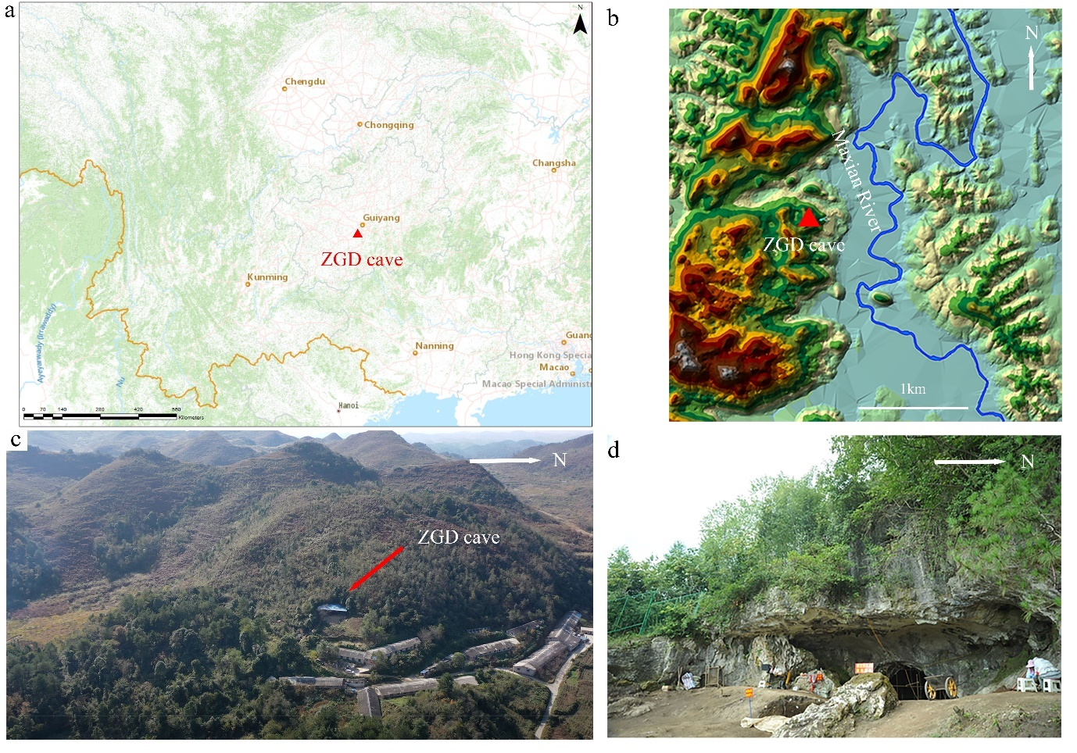

Figure 1. (a) Location of Zhaoguodong cave (ZGD cave). (b) Topography near the cave. (c) Bird's-eye view of the cave entrance. (d) Close look of the cave entrance.

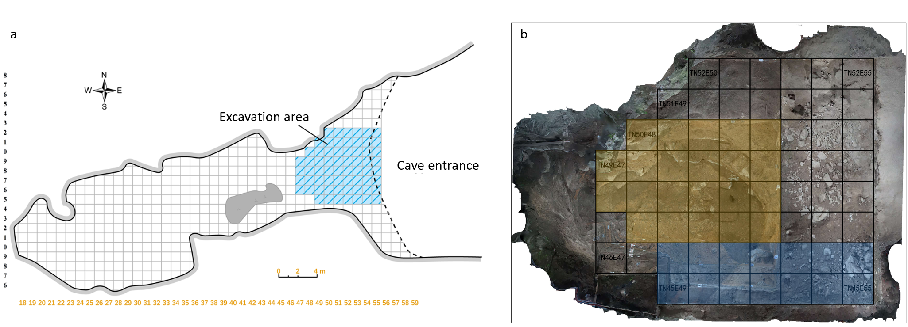

Figure 2. (a) A plane view of the cave. (b) The blue area indicates the new pits of 2020, and the yellow area indicates subsequent excavations in 2020 that follow on layer 19.

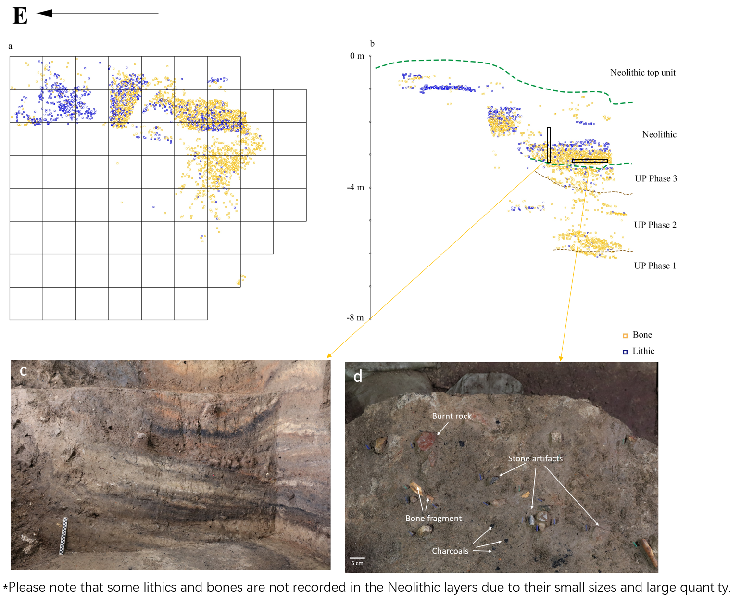

Figure 3. Horizontal (a) and vertical (b) plots of the 2020 excavation area. c) vertical view of overlap fireplaces; d) photography of excavation plane.

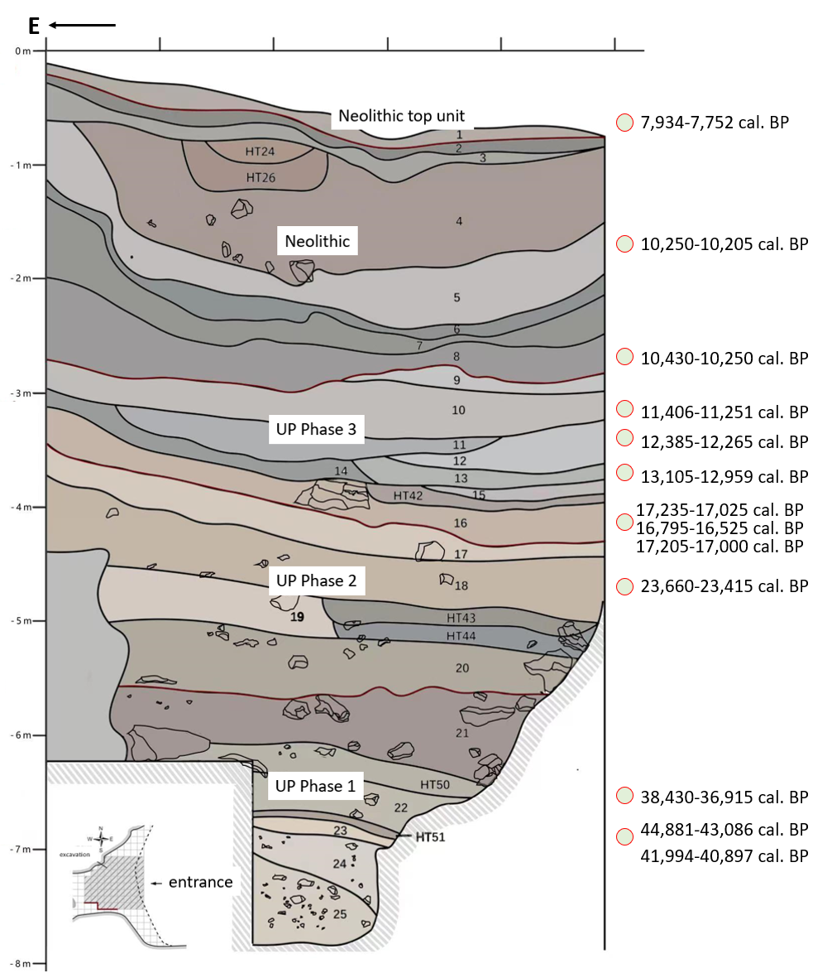

Figure 4. The stratigraphical profile of Zhaoguodong cave (UP: Upper Palaeolithic; HT: fireplace). Key 14C results are showing on left.

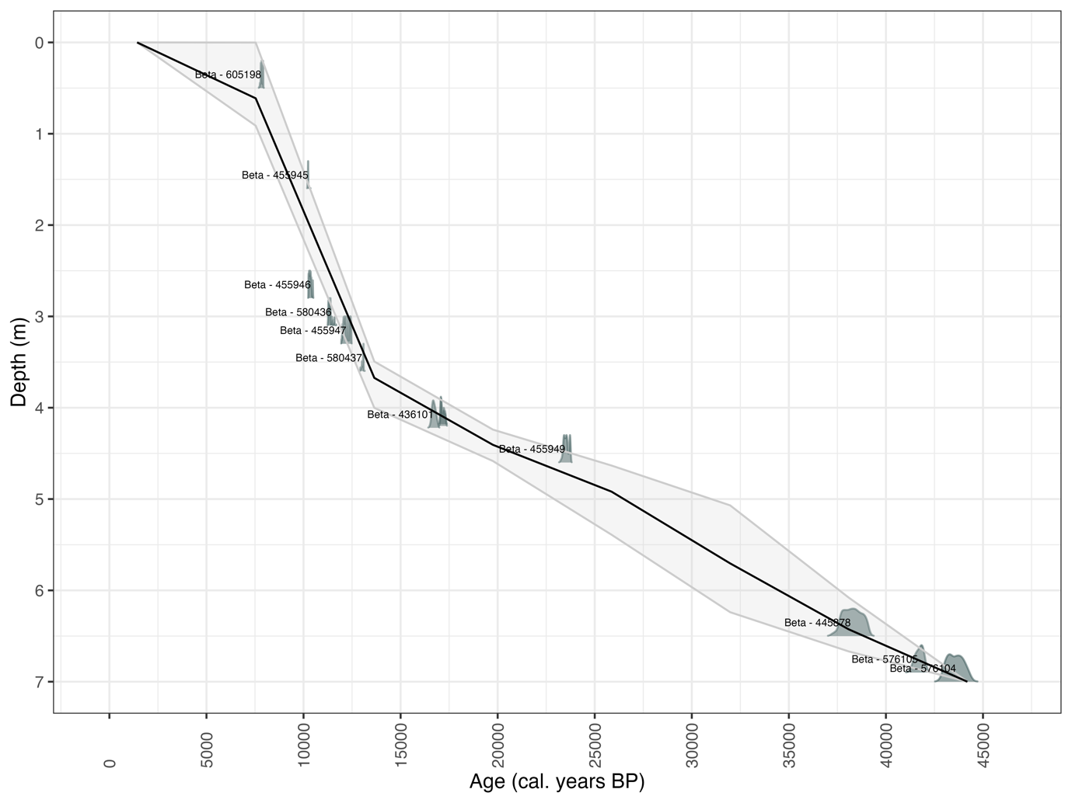

Figure 5. Age-depth plot of calibrated radiocarbon dates for Zhaoguodong cave. Calibrations were computed using Bchron software (Haslett and Parnell 2008) and the IntCal20 atmospheric curve (Reimer et al., 2020)

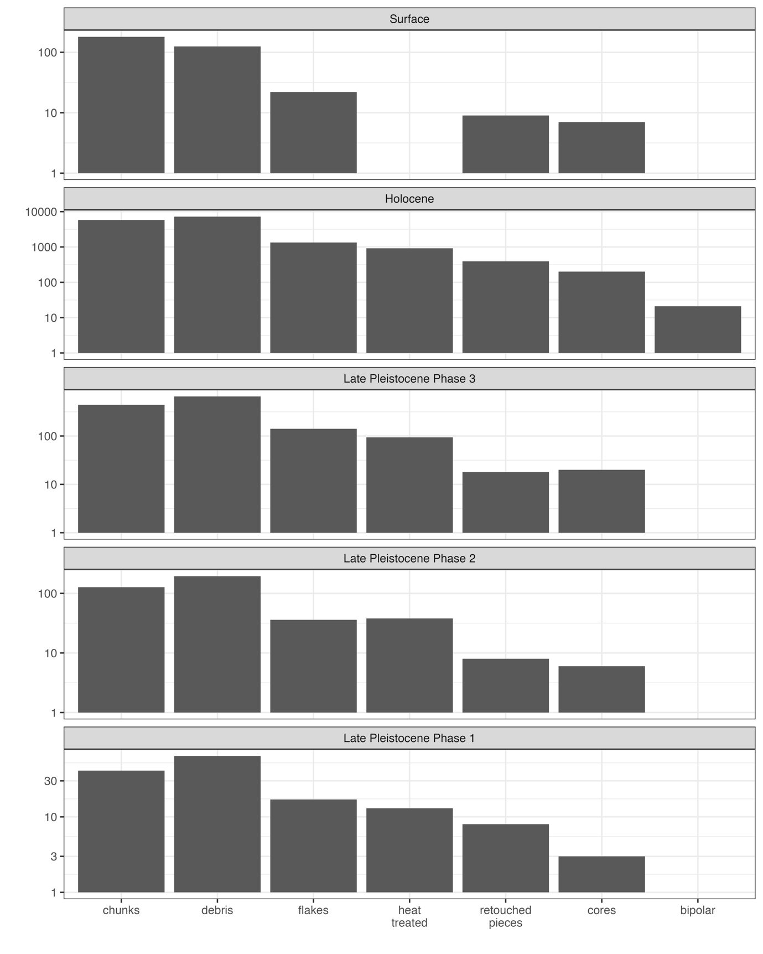

Figure 6. Counts of assemblage components (cores, flakes, retouched tools, debris, chunks, burnt rocks, and minerals) for each phase.

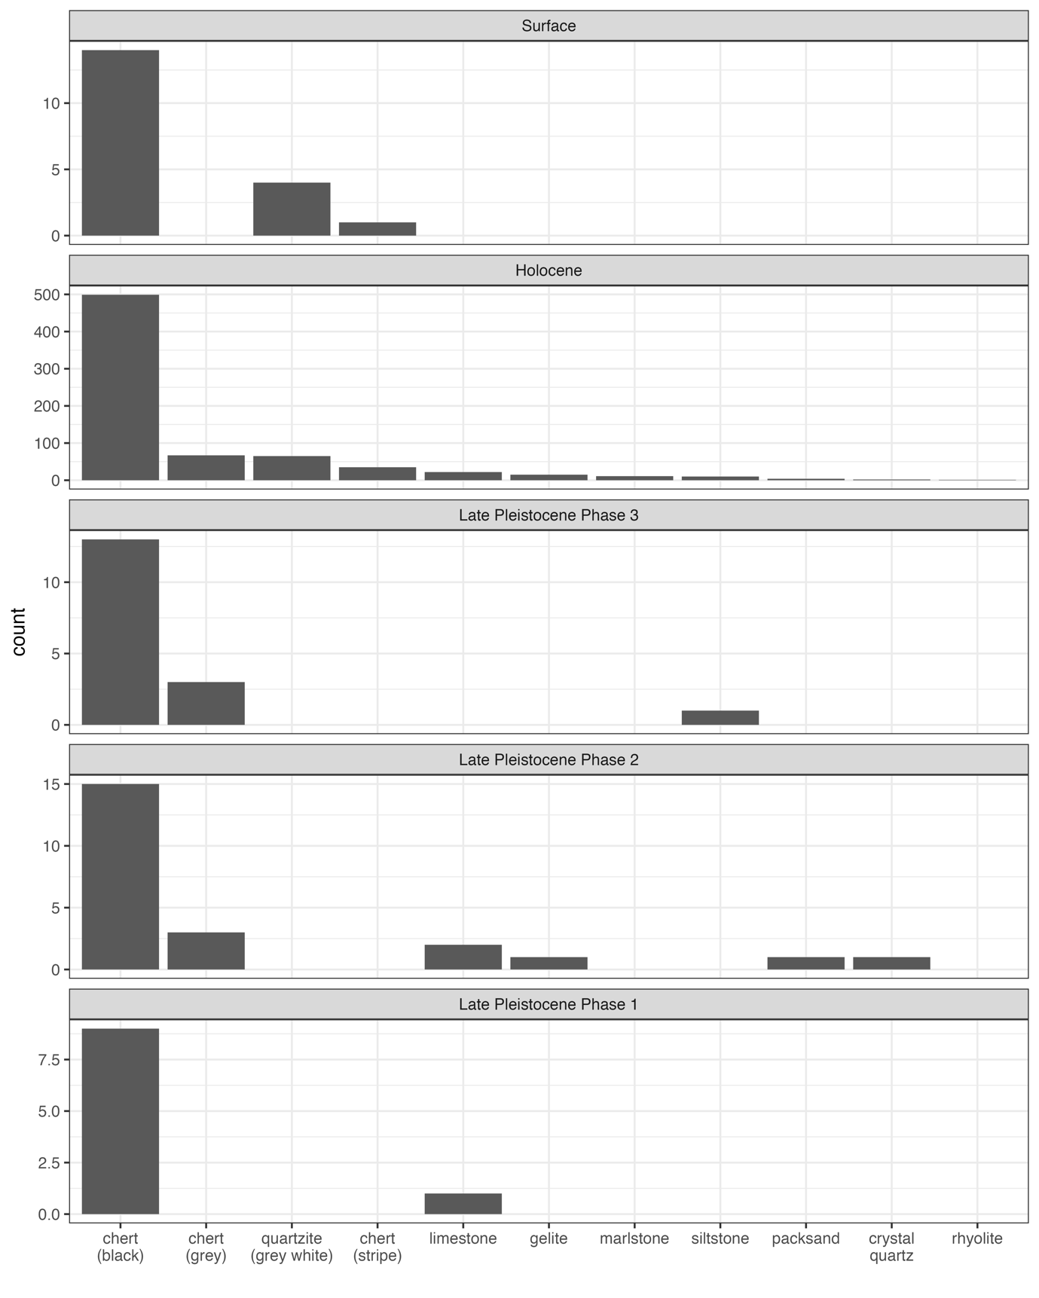

Figure 7. Counts of lithic raw materials for each phase.

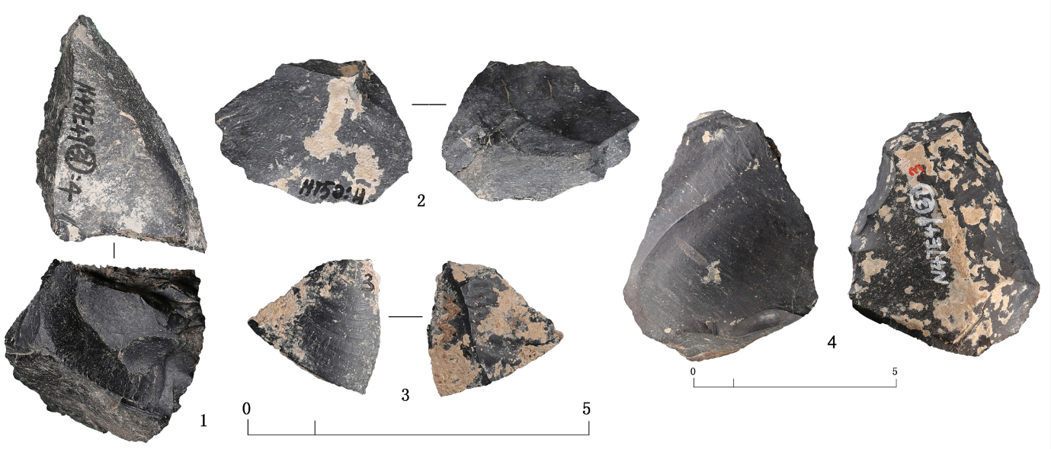

Figure 8. Selected stone artefacts from phase 1 (1 core; 2-3 flakes; and 4 scraper).

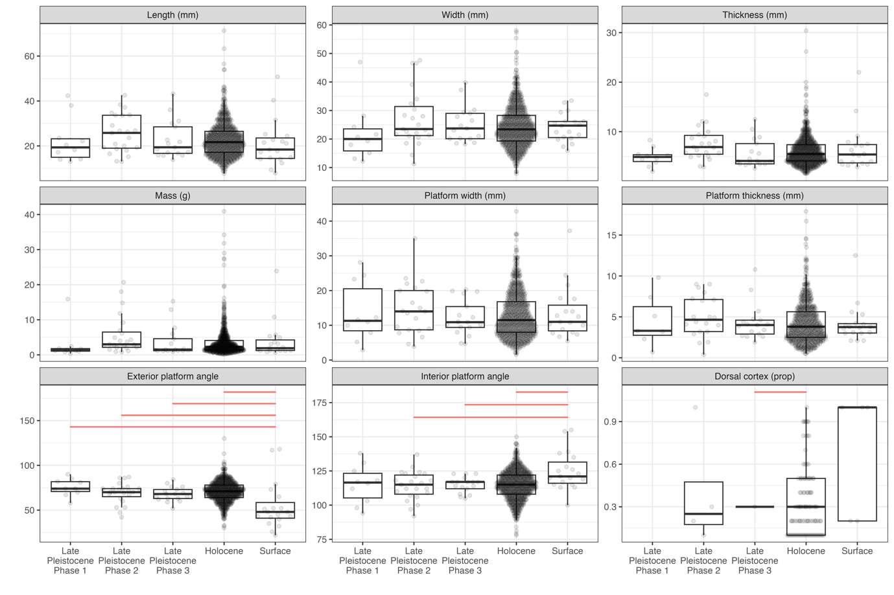

Figure 9. Boxplots summarizing variation in flake dimensions and technological attributes. The horizontal red lines in the upper part of some panels indicate statistically significant differences (p < 0.05) in metrics between phases, computed by ANOVA.

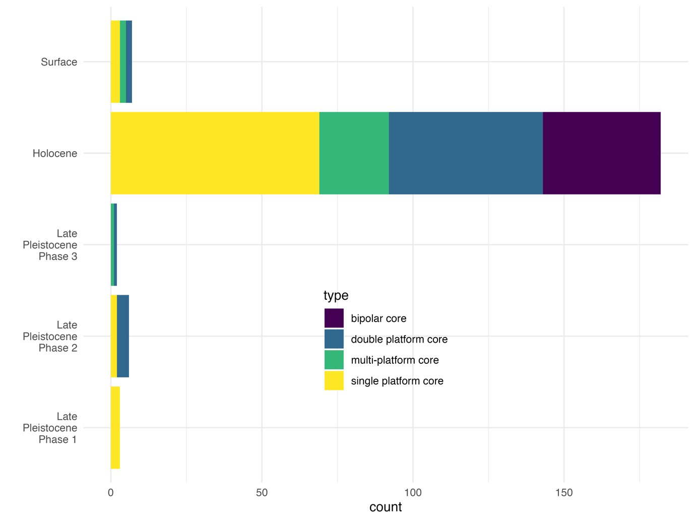

Figure X. Barplot summarizing variation in counts of core types in the occupational phases.

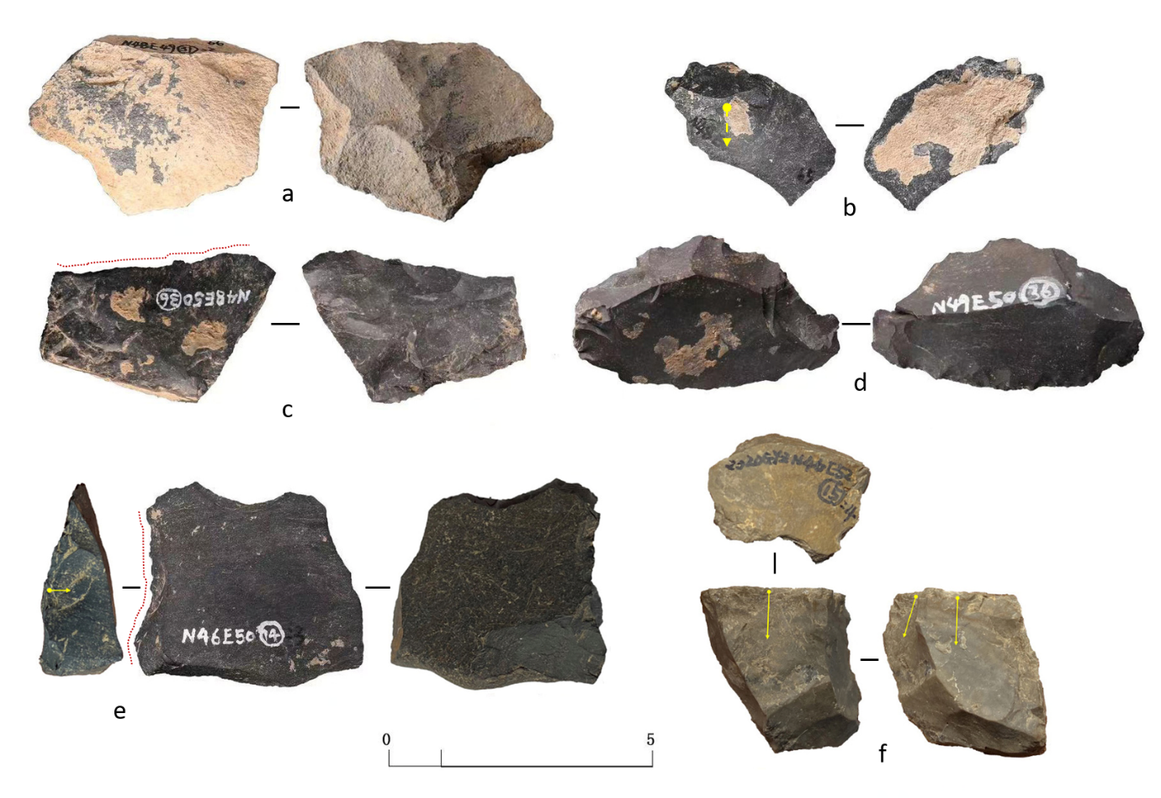

Figure 10. Selected stone artefacts from phase 2 (a, b flakes, c scrappers, d denticulates, e notch, and f core). Please enlarged photos of a, d, f, e in SOM Figure S71, S72, S68, S67.

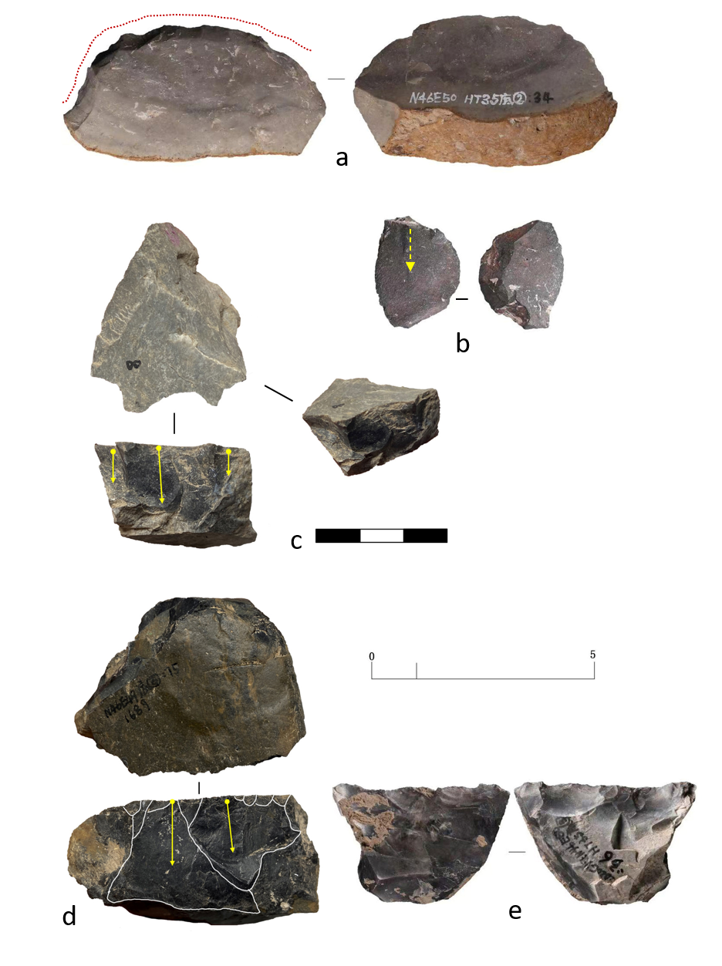

Figure 11. Selected stone artefacts from phase 3 (a scrapper; b flake; c, d cores; and e scraper). Please enlarged photos of a, c, d, e in SOM Figure S57, S58, S59, S56.

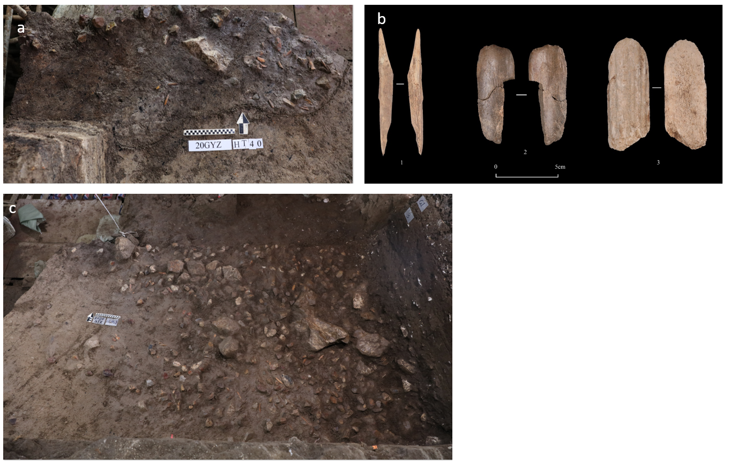

Figure 12. a) Plane view of fireplace HT40; b) Selected bone tools from Zhaoguodong cave (1 awl; 2 bone spatula; and 3 antler spatula); and c) Plane view of stone floor HDM8.

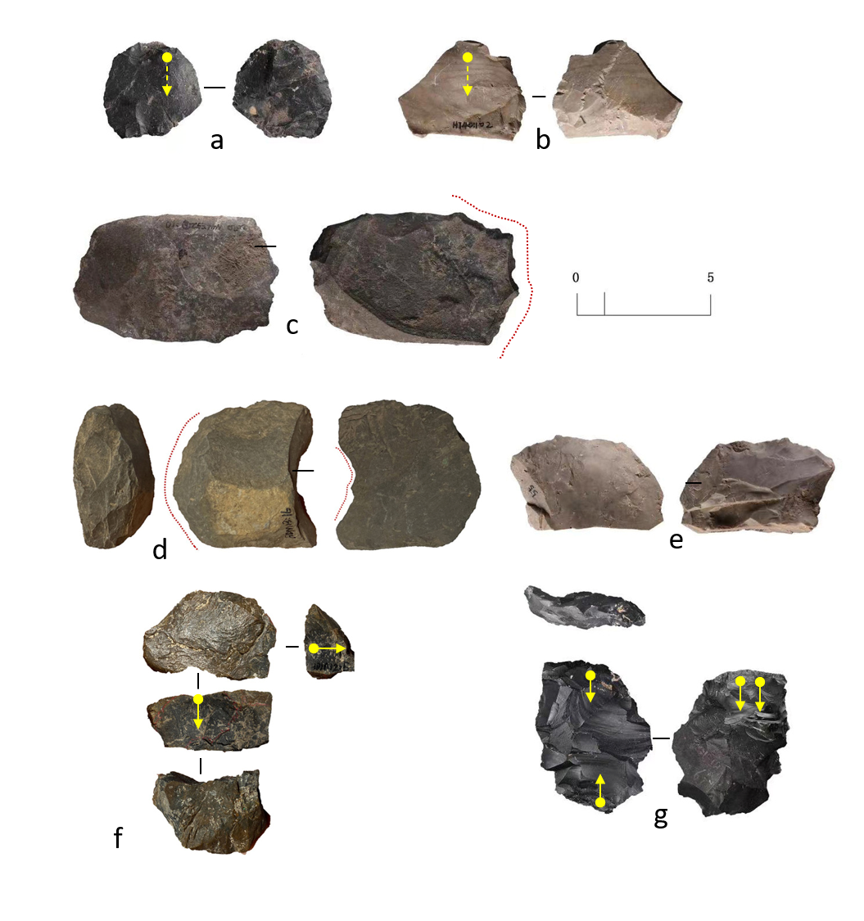

Figure 13. Selected stone artefacts from Neolithic assemblages (a bipolar flake; b flake; c Denticulate; e scraper; d notch; f core; and g bipolar core). Please enlarged photos of d, f in SOM Figure S18, S17.

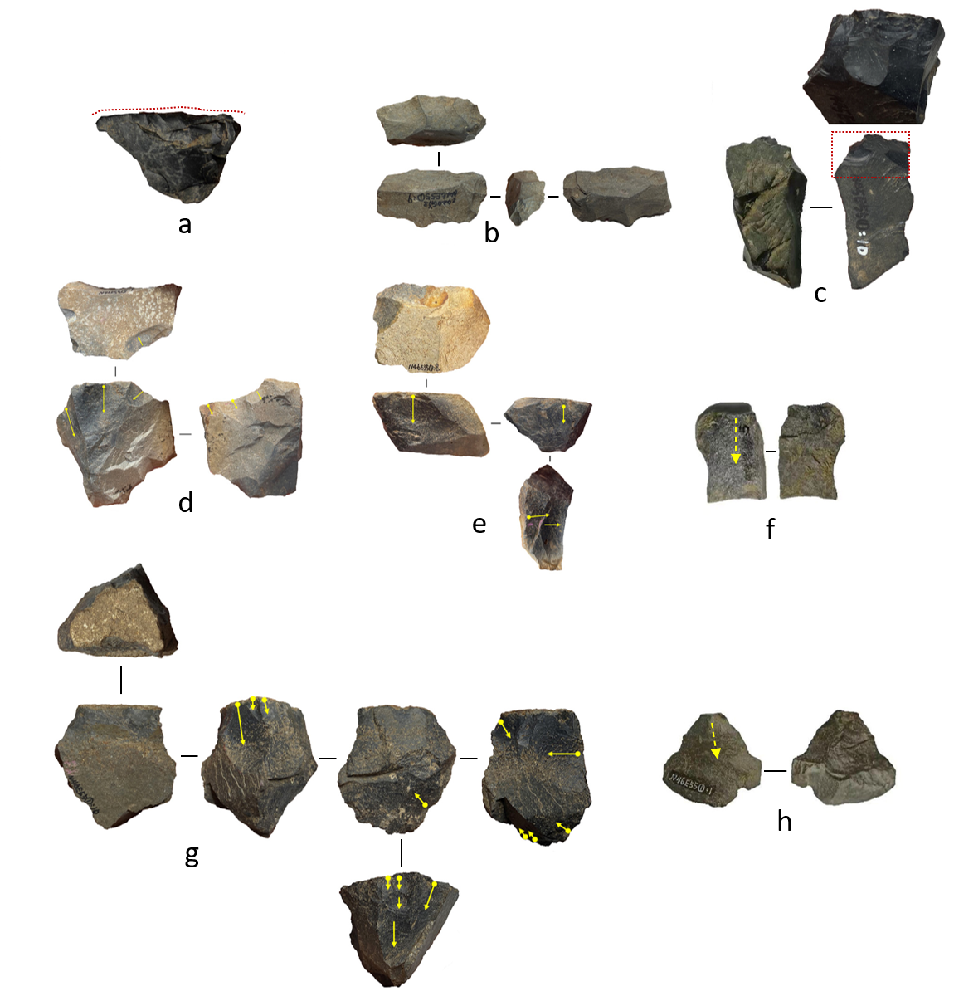

Figure 14. Selected stone artefacts from the surface unit (f, h flakes; c scraper; d, e, g cores; a scraper; and b denticulate). Please enlarged photos of d, g in SOM Figure S13, S7.

# Reference

Allen, J., O’Connell, J., 2014. Both half right:Updating the evidence for dating first human arrivals in Sahul. Australian Archaeology 79, 86-108.

Anisyutkin, N.K., Timofeyev, V.I., 2006. The Paleolithic flake industry in Vietnam. Archaeology, Ethnology and Anthropology of Eurasia V27, 16-24.

Aubert, M., Brumm, A., Ramli, M., Sutikna, T., Saptomo, E.W., Hakim, B., Morwood, M.J., van den Bergh, G.D., Kinsley, L., Dosseto, A.J.N., 2014. Pleistocene cave art from Sulawesi, Indonesia. 514, 223-227.

Bar-Yosef, O., Wang, Y., 2012. Paleolithic Archaeology in China. Annual Review of Anthropology 41, 319-335.

Barker, G., Barton, H., Cole, F., Doherty, C.B.R., Gilbertson, D.D., Hunt, C., Lloyd-Smith, L., Piper, P.J., Rabett, R., Reynolds, T.E., Szabó, K., 2013. The Niah Caves, the 'Human Revolution', and foraging/farming transitions.

Björck, S., Kromer, B., Johnsen, S., Bennike, O., Hammarlund, D., Lemdahl, G., Possnert, G., Rasmussen, T.L., Wohlfarth, B., Hammer, C.U., Spurk, M., 1996. Synchronized Terrestrial Atmospheric Deglacial Records Around the North Atlantic. Science 274, 1155-1160.

Blinkhorn, J., Achyuthan, H., Petraglia, M., Ditchfield, P., 2013. Middle Palaeolithic occupation in the Thar Desert during the Upper Pleistocene: the signature of a modern human exit out of Africa? Quaternary Science Reviews 77, 233-238.

Boulanger, C., Ingicco, T., Piper, P.J., Amano, N., Grouard, S., Ono, R., Hawkins, S., Pawlik, A.F.J.T.J.o.I., Archaeology, C., 2019. Coastal subsistence strategies and mangrove swamp evolution at Bubog I Rockshelter (Ilin Island, Mindoro, Philippines) from the Late Pleistocene to the mid-Holocene. 14, 584-604.

Bowler, J.M., Johnston, H., Olley, J.M., Prescott, J.R., Roberts, R.G., Shawcross, W., Spooner, N.A., 2003. New ages for human occupation and climatic change at Lake Mungo, Australia. Nature 421, 837-840.

Brumm, A., Langley, M.C., Moore, M.W., Hakim, B., Ramli, M., Sumantri, I., Burhan, B., Saiful, A.M., Siagian, L., Sciences, S.J.P.o.t.N.A.o., 2017. Early human symbolic behavior in the Late Pleistocene of Wallacea. 114, 4105-4110.

Buizert, C., Gkinis, V., Severinghaus, J.P., He, F., Lecavalier, B.S., Kindler, P., Leuenberger, M., Carlson, A.E., Vinther, B., Masson-Delmotte, V., White, J.W.C., Liu, Z., Otto-Bliesner, B., Brook, E.J., 2014. Greenland temperature response to climate forcing during the last deglaciation. Science 345, 1177-1180.

Chen, Z.W., Li, J.J., Yu, S.F., 2001. A paleolithic site at Chuanfandong in Sanming city, Fujian province. Acta Anthropol. Sin. 20, 756-270.

Chi, Z., Hung, H.-C., 2008. The Neolithic of Southern China—Origin, Development, and Dispersal. Asian Perspectives 47, 299-329.

Chitkament, T., Gaillard, C., Shoocongdej, R., 2016. Tham Lod rockshelter (Pang Mapha district, north-western Thailand): Evolution of the lithic assemblages during the late Pleistocene. Quaternary International 416, 151-161.

Clarkson, C., Harris, C., Li, B., Neudorf, C.M., Roberts, R.G., Lane, C., Norman, K., Pal, J., Jones, S., Shipton, C., Koshy, J., Gupta, M.C., Mishra, D.P., Dubey, A.K., Boivin, N., Petraglia, M., 2020. Human occupation of northern India spans the Toba super-eruption ~74,000 years ago. Nature Communications 11, 961.

Clarkson, C., Jones, S., Harris, C., 2012. Continuity and change in the lithic industries of the Jurreru Valley, India, before and after the Toba eruption. Quaternary International 258, 165-179.

Clarkson, C., Petraglia, M., Korisettar, R., Haslam, M., Boivin, N., Crowther, A., Ditchfield, P., Fuller, D., Miracle, P., Harris, C., 2009. The oldest and longest enduring microlithic sequence in India: 35 000 years of modern human occupation and change at the Jwalapuram Locality 9 rockshelter. Antiquity 83, 326-348.

Clarkson, C., Smith, M., Marwick, B., Fullagar, R., Wallis, L.A., Faulkner, P., Manne, T., Hayes, E., Roberts, R.G., Jacobs, Z., 2015. The archaeology, chronology and stratigraphy of Madjedbebe (Malakunanja II): A site in northern Australia with early occupation. Journal of Human Evolution 83, 46-64.

Cohen, D.J., 2011. The beginnings of agriculture in china: A multiregional view. Current Anthropology 52, S273-S293.

Curnoe, D., Datan, I., Taçon, P.S.C., Leh Moi Ung, C., Sauffi, M.S., 2016. Deep Skull from Niah Cave and the Pleistocene Peopling of Southeast Asia. 4.

Curnoe, D., Ji, X., Taçon, P.S.C., Yaozheng, G., 2015. Possible Signatures of Hominin Hybridization from the Early Holocene of Southwest China. Scientific Reports 5, 12408.

de la Torre, I., Benito-Calvo, A., Proffitt, T., 2018. The impact of hydraulic processes in Olduvai Beds I and II, Tanzania, through a particle dimension analysis of stone tool assemblages. Geoarchaeology 33, 218-236.

Demeter, F., Shackelford, L., Westaway, K., Barnes, L., Duringer, P., Ponche, J.-L., Dumoncel, J., Sénégas, F., Sayavongkhamdy, T., Zhao, J.-X., Sichanthongtip, P., Patole-Edoumba, E., Dunn, T., Zachwieja, A., Coppens, Y., Willerslev, E., Bacon, A.-M., 2017. Early Modern Humans from Tam Pà Ling, Laos: Fossil Review and Perspectives. Current Anthropology 58, S527-S538.

Dennell, R., Petraglia, M.D., 2012. The dispersal of Homo sapiens across southern Asia: how early, how often, how complex? Quaternary Science Reviews 47, 15-22.

Denniston, R.F., Gonzalez, L.A., Asmerom, Y., Polyak, V., Reagan, M.K., Saltzman, M.R., 2001. A high-resolution speleothem record of climatic variability at the Allerød–Younger Dryas transition in Missouri, central United States. Palaeogeography, Palaeoclimatology, Palaeoecology 176, 147-155.

Detroit, F., Dizon, E., Falgueres, C., Hameau, S., Ronquillo, W., Semah, F., 2004. Upper Pleistocene Homo sapiens from the Tabon cave (Palawan, The Philippines): description and dating of new discoveries. Comptes Rendus Palevol 3, 705-712.

Devièse, T., Karavanić, I., Comeskey, D., Kubiak, C., Korlević, P., Hajdinjak, M., Radović, S., Procopio, N., Buckley, M., Pääbo, S., Higham, T., 2017. Direct dating of Neanderthal remains from the site of Vindija Cave and implications for the Middle to Upper Paleolithic transition. Proceedings of the National Academy of Sciences 114, 10606.

Drake, N.A., Blench, R.M., Armitage, S.J., Bristow, C.S., White, K.H.J.P.o.t.N.A.o.S., 2011. Ancient watercourses and biogeography of the Sahara explain the peopling of the desert. 108, 458-462.

Fu, Q., Li, H., Moorjani, P., Jay, F., Slepchenko, S.M., Bondarev, A.A., Johnson, P.L., Aximu-Petri, A., Prüfer, K., De Filippo, C.J.N., 2014. Genome sequence of a 45,000-year-old modern human from western Siberia. 514, 445-449.

Fuentes, R., Ono, R., Nakajima, N., Nishizawa, H., Siswanto, J., Aziz, N., Sriwigati, Sofian, H.O., Miranda, T., Pawlik, A., 2019. Technological and behavioural complexity in expedient industries: The importance of use-wear analysis for understanding flake assemblages. Journal of Archaeological Science 112, 105031.

Gibbs, K., Jordan, P., 2016. A comparative perspective on the ‘western’ and ‘eastern’ Neolithics of Eurasia: Ceramics; agriculture and sedentism. Quaternary International 419, 27-35.

Glover, I., 1981. Leang Burung 2: An Upper Palaeolithic rock shelter in South Sulawesi, Indonesia. Modern Quaternary Research in South East Asia 6, 1-38.

Guo, Y.-J., Li, B., Zhang, J.-F., Yuan, B.-Y., Xie, F., Roberts Richard, G., 2017. New ages for the Upper Palaeolithic site of Xibaimaying in the Nihewan Basin, northern China: implications for small-tool and microblade industries in north-east Asia during Marine Isotope Stages 2 and 3. Journal of Quaternary Science 32, 540-552.

Gutenkunst, R.N., Hernandez, R.D., Williamson, S.H., Bustamante, C.D., 2009. Inferring the Joint Demographic History of Multiple Populations from Multidimensional SNP Frequency Data. PLOS Genetics 5, e1000695.

Habgood, P.J., Franklin, N.R., 2008. The revolution that didn't arrive: A review of Pleistocene Sahul. Journal of Human Evolution 55, 187-222.

Hamm, G., Mitchell, P., Arnold, L.J., Prideaux, G.J., Questiaux, D., Spooner, N.A., Levchenko, V.A., Foley, E.C., Worthy, T.H., Stephenson, B., Coulthard, V., Coulthard, C., Wilton, S., Johnston, D., 2016. Cultural innovation and megafauna interaction in the early settlement of arid Australia. Nature 539, 280-283.

Hershkovitz, I., Marder, O., Ayalon, A., Bar-Matthews, M., Yasur, G., Boaretto, E., Caracuta, V., Alex, B., Frumkin, A., Goder-Goldberger, M.J.N., 2015. Levantine cranium from Manot Cave (Israel) foreshadows the first European modern humans. 520, 216-219.

Hu, X.C., Gao, X., 2022. A preliminary study of the stone artifacts unearthed from the Ma’anshan site of Guizhou province in 1986. Acta Anthropol. Sin. 41, 788-803.

Hu, Y., Shang, H., Tong, H., Nehlich, O., Liu, W., Zhao, C., Yu, J., Wang, C., Trinkaus, E., Richards, M.P., 2009. Stable isotope dietary analysis of the Tianyuan 1 early modern human. Proc Natl Acad Sci U S A 106, 10971-10974.

Hublin, J.-J.J.P.o.t.N.A.o.S., 2012. The earliest modern human colonization of Europe. 109, 13471-13472.

Hunt, C., Barker, G., 2014. Missing links, cultural modernity and the dead: anatomically modern humans in the Great Cave of Niah (Sarawak, Borneo), in: Dennell, R., Porr, M. (Eds.), Southern Asia, Australia, and the Search for Human Origins. Cambridge University Press, Cambridge, pp. 90-107.

Ji, X., Kuman, K., Clarke, R.J., Forestier, H., Li, Y., Ma, J., Qiu, K., Li, H., Wu, Y., 2016. The oldest Hoabinhian technocomplex in Asia (43.5 ka) at Xiaodong rockshelter, Yunnan Province, southwest China. Quaternary International, <http://dx.doi.org/10.1016/j.quaint.2015.1009.1080>.

Jiang, J.Y., 2006. Study of Bailian Dong, Miaoyan and Xianren Dong archaeological site: case analysis of transitional period from Palaeolithic to Neolithic epoch. Prehistoric Res., 58-67.

Jones, M.K., Liu, X., 2009. Origins of Agriculture in East Asia. Science 324, 730-731.

Jordan, P., Zvelebil, M.J.T.D.o.P.A.P.E.H.-G.L., England: Institute of Archaeology, University College London, 2009. Ceramics before farming.

Keally, C.T., Taniguchi, Y., Kuzmin, Y.V., Shewkomud, I.Y., 2004. Chronology of the Beginning of Pottery Manufacture in East Asia. Radiocarbon 46, 345-351.

Kong, Q.-P., Sun, C., Wang, H.-W., Zhao, M., Wang, W.-Z., Zhong, L., Hao, X.-D., Pan, H., Wang, S.-Y., Cheng, Y.-T., Zhu, C.-L., Wu, S.-F., Liu, L.-N., Jin, J.-Q., Yao, Y.-G., Zhang, Y.-P., 2011. Large-Scale mtDNA Screening Reveals a Surprising Matrilineal Complexity in East Asia and Its Implications to the Peopling of the Region. Molecular Biology and Evolution 28, 513-522.

Kuman, K., 2003. Site formation in the early South African Stone Age sites and its influence on the archaeological record : reviews of current issues and research findings : human origins research in South Africa. South African Journal of Science 99, 251-254.

Leavesley, M.G., 2007. A shark-tooth ornament from Pleistocene Sahul. Antiquity 81, 308-315.

Lewis, L., 2015. Early Microlithic Technologies and Behavioural Variability in Southern Africa and South Asia. University of Oxford.

Li, F., Bae, C.J., Ramsey, C.B., Chen, F., Gao, X., 2018. Re-dating Zhoukoudian Upper Cave, northern China and its regional significance. Journal of Human Evolution 121, 170-177.

Li, F., Kuhn, S.L., Gao, X., Chen, F.-y., 2013. Re-examination of the dates of large blade technology in China: A comparison of Shuidonggou Locality 1 and Locality 2. Journal of Human Evolution 64, 161-168.

Li, H., Li, Y., Yu, L., Tu, H., Zhang, Y., Sumner, A., Kuman, K., 2022. Continuous technological and behavioral development of late Pleistocene hominins in central South China: Multidisciplinary analysis at Sandinggai. Quaternary Science Reviews 298, 107850.

Li, H., Wu, X., Li, S., Huang, W., Liu, W.J.C.s.b., 2010. Late pleistocene human skull from Jingchuan, Gansu Province. 55, 1047-1052.

Lipson, M., Cheronet, O., Mallick, S., Rohland, N., Oxenham, M., Pietrusewsky, M., Pryce, T.O., Willis, A., Matsumura, H., Buckley, H., Domett, K., Nguyen, G.H., Trinh, H.H., Kyaw, A.A., Win, T.T., Pradier, B., Broomandkhoshbacht, N., Candilio, F., Changmai, P., Fernandes, D., Ferry, M., Gamarra, B., Harney, E., Kampuansai, J., Kutanan, W., Michel, M., Novak, M., Oppenheimer, J., Sirak, K., Stewardson, K., Zhang, Z., Flegontov, P., Pinhasi, R., Reich, D., 2018. Ancient genomes document multiple waves of migration in Southeast Asian prehistory. Science 361, 92-95.

Liu, L., Bestel, S., Shi, J., Song, Y., Chen, X., 2013. Paleolithic human exploitation of plant foods during the last glacial maximum in North China. Proceedings of the National Academy of Sciences 110, 5380-5385.

Madsen, David, B., Li, Jingzen, Brantingham, P., Jeffrey, Gao, Antiquity, X.J., 2001. Dating Shuidonggou and the Upper Palaeolithic blade industry in North Carolina.

Maloney, T., O'Connor, S., Wood, R., Aplin, K., Balme, J., 2018. Carpenters Gap 1: A 47,000 year old record of indigenous adaption and innovation. Quaternary Science Reviews 191, 204-228.

Mao, Y.Q., Cao, Z.T., 2012. A preliminary study of the polished bone tools unearthed in 1979 from the Chuandong site in Puding County, Guizhou. Acta Anthropol. Sin. 31, 335-343.

Marean, C.W., Bar-Matthews, M., Bernatchez, J., Fisher, E., Goldberg, P., Herries, A.I.R., Jacobs, Z., Jerardino, A., Karkanas, P., Minichillo, T., Nilssen, P.J., Thompson, E., Watts, I., Williams, H.M., 2007. Early human use of marine resources and pigment in South Africa during the Middle Pleistocene Nature 448, 905-907.

Marwick, B., Clarkson, C., O'Connor, S., Collins, S., 2016. Early modern human lithic technology from Jerimalai, East Timor. Journal of Human Evolution 101, 45-64.

McBrearty, S., Brooks, A.S., 2000. The revolution that wasn't: a new interpretation of the origin of modern human behavior. Journal of Human Evolution 39, 453-563.

McColl, H., Racimo, F., Vinner, L., Demeter, F., Gakuhari, T., Moreno-Mayar, J.V., van Driem, G., Gram Wilken, U., Seguin-Orlando, A., de la Fuente Castro, C., Wasef, S., Shoocongdej, R., Souksavatdy, V., Sayavongkhamdy, T., Saidin, M.M., Allentoft, M.E., Sato, T., Malaspinas, A.-S., Aghakhanian, F.A., Korneliussen, T., Prohaska, A., Margaryan, A., de Barros Damgaard, P., Kaewsutthi, S., Lertrit, P., Nguyen, T.M.H., Hung, H.-c., Minh Tran, T., Nghia Truong, H., Nguyen, G.H., Shahidan, S., Wiradnyana, K., Matsumae, H., Shigehara, N., Yoneda, M., Ishida, H., Masuyama, T., Yamada, Y., Tajima, A., Shibata, H., Toyoda, A., Hanihara, T., Nakagome, S., Deviese, T., Bacon, A.-M., Duringer, P., Ponche, J.-L., Shackelford, L., Patole-Edoumba, E., Nguyen, A.T., Bellina-Pryce, B., Galipaud, J.-C., Kinaston, R., Buckley, H., Pottier, C., Rasmussen, S., Higham, T., Foley, R.A., Lahr, M.M., Orlando, L., Sikora, M., Phipps, M.E., Oota, H., Higham, C., Lambert, D.M., Willerslev, E., 2018. The prehistoric peopling of Southeast Asia. Science 361, 88-92.

Mellars, P., Gori, K.C., Carr, M., Soares, P.A., Richards, M.B., 2013. Genetic and archaeological perspectives on the initial modern human colonization of southern Asia. Proceedings of the National Academy of Sciences 110, 10699-10704.

Mishra, S., Chauhan, N., Singhvi, A.K., 2013. Continuity of microblade technology in the Indian Subcontinent since 45 ka: implications for the dispersal of modern humans. PLoS ONE 8, e69280.

Moore, M.W., Sutikna, T., Jatmiko, Morwood, M.J., Brumm, A., 2009. Continuities in stone flaking technology at Liang Bua, Flores, Indonesia. Journal of Human Evolution 57, 503-526.

Morwood, M.J., Sutikna, T., Saptomo, E.W., Westaway, K.E., Jatmiko, Awe Due, R., Moore, M.W., Yuniawati, D.Y., Hadi, P., Zhao, J.x., Turney, C.S.M., Fifield, K., Allen, H., Soejono, R.P., 2008. Climate, people and faunal succession on Java, Indonesia: evidence from Song Gupuh. Journal of Archaeological Science 35, 1776-1789.

Mudar, K., Anderson, D., 2007. New evidence for Southeast Asian Pleistocene foraging economies: faunal remains from the early levels of Lang Rongrien rockshelter, Krabi, Thailand. Asian Perspectives 46, 298-334.

Nicole Boivin, D.Q.F., Robin Dennell, Robin Allaby, Michael D. Petraglia, 2013. Human Dispersal Across Diverse Environments of Asia during the Upper Pleistocene. Quaternary International.

Niu, D., Pei, S., Zhang, S., Zhou, Z., Wang, H., Gao, X., 2016. The Initial Upper Palaeolithic in Northwest China: New evidence of cultural variability and change from Shuidonggou locality 7. Quaternary International 400, 111-119.

Norton Christopher, J., Jin Jennie, J.H., 2009. The evolution of modern human behavior in East Asia: Current perspectives. Evolutionary Anthropology: Issues, News, and Reviews 18, 247-260.

O'Connor, S., Carro, S.C.S., Hawkins, S., Kealy, S., Louys, J., Wood, R.J.a., 2017. Fishing in life and death: Pleistocene fish-hooks from a burial context on Alor Island, Indonesia. 91, 1451-1468.

O'Connor, S., Robertson, G., Aplin, K.P., 2014. Are osseous artefacts a window to perishable material culture? Implications of an unusually complex bone tool from the Late Pleistocene of East Timor. Journal of Human Evolution 67, 108-119.

O’Connor, S., Ono, R., Clarkson, C., 2011. Pelagic Fishing at 42,000 Years Before the Present and the Maritime Skills of Modern Humans. Science 334, 1117-1121.

Patole-Edoumba, E., Pawlik, A.F., Mijares, A.S., 2012. Evolution of prehistoric lithic industries of the Philippines during the Pleistocene. Comptes Rendus Palevol 11, 213-230.

Pei, W., 1939. The upper cave industry of Choukoutien. Geological Survey of China.

Perera, N., Kourampas, N., Simpson, I.A., Deraniyagala, S.U., Bulbeck, D., Kamminga, J., Perera, J., Fuller, D.Q., Szabó, K., Oliveira, N.V., 2011. People of the ancient rainforest: Late Pleistocene foragers at the Batadomba-lena rockshelter, Sri Lanka. Journal of Human Evolution 61, 254-269.

Petraglia, M., Clarkson, C., Boivin, N., Haslam, M., Korisettar, R., Chaubey, G., Ditchfield, P., Fuller, D., James, H., Jones, S., Kivisild, T., Koshy, J., Lahr, M.M., Metspalu, M., Roberts, R., Arnold, L., 2009. Population increase and environmental deterioration correspond with microlithic innovations in South Asia ca. 35,000 years ago. Proceedings of the National Academy of Sciences 106, 12261-12266.

Petraglia, M., Potts, R., 1994. Water flow and the formation of Early Pleistocene artifacts sites in Olduvai Gorge, Tanzania Journal of Anthropological Archaeology 13, 228-254.

Powell, A., Shennan, S., Thomas, M.G., 2009. Late Pleistocene Demography and the Appearance of Modern Human Behavior. Science 324, 1298-1301.

Qu, T., Bar-Yosef, O., Wang, Y., Wu, X., 2013. The Chinese Upper Paleolithic: Geography, Chronology, and Techno-typology. Journal of Archaeological Research 21, 1-73.

Rasmussen, M., Guo, X., Wang, Y., Lohmueller, K.E., Rasmussen, S., Albrechtsen, A., Skotte, L., Lindgreen, S., Metspalu, M., Jombart, T., Kivisild, T., Zhai, W., Eriksson, A., Manica, A., Orlando, L., De La Vega, F., Tridico, S., Metspalu, E., Nielsen, K., Ávila-Arcos, M.C., Moreno-Mayar, J.V., Muller, C., Dortch, J., Gilbert, M.T.P., Lund, O., Wesolowska, A., Karmin, M., Weinert, L.A., Wang, B., Li, J., Tai, S., Xiao, F., Hanihara, T., van Driem, G., Jha, A.R., Ricaut, F.-X., de Knijff, P., Migliano, A.B., Gallego-Romero, I., Kristiansen, K., Lambert, D.M., Brunak, S., Forster, P., Brinkmann, B., Nehlich, O., Bunce, M., Richards, M., Gupta, R., Bustamante, C.D., Krogh, A., Foley, R.A., Lahr, M.M., Balloux, F., Sicheritz-Pontén, T., Villems, R., Nielsen, R., Jun, W., Willerslev, E., 2011. An Aboriginal Australian Genome Reveals Separate Human Dispersals into Asia. Science.

Rasmussen, S.O., Andersen, K.K., Svensson, A.M., Steffensen, J.P., Vinther, B.M., Clausen, H.B., Siggaard-Andersen, M.L., Johnsen, S.J., Larsen, L.B., Dahl-Jensen, D., Bigler, M., Röthlisberger, R., Fischer, H., Goto-Azuma, K., Hansson, M.E., Ruth, U., 2006. A new Greenland ice core chronology for the last glacial termination. Journal of Geophysical Research: Atmospheres 111.

Reti, J.S.J.P.O., 2016. Quantifying Oldowan stone tool production at Olduvai Gorge, Tanzania. 11, e0147352.

Revedin, A., Aranguren, B., Becattini, R., Longo, L., Marconi, E., Lippi, M.M., Skakun, N., Sinitsyn, A., Spiridonova, E., Svoboda, J., 2010. Thirty thousand-year-old evidence of plant food processing. Proceedings of the National Academy of Sciences 107, 18815-18819.

Roberts, P., Boivin, N., Petraglia, M., 2015. The Sri Lankan ‘Microlithic’ Tradition c. 38,000 to 3,000 Years Ago: Tropical Technologies and Adaptations of Homo sapiens at the Southern Edge of Asia. Journal of World Prehistory 28, 69-112.

Roberts, P., Stewart, B.A., 2018. Defining the ‘generalist specialist’ niche for Pleistocene Homo sapiens. Nature Human Behaviour 2, 542-550.

Shang, H., Tong, H., Zhang, S., Chen, F., Trinkaus, E., 2007. An early modern human from Tianyuan Cave, Zhoukoudian, China. PNAS, 0702169104.

Shipton, C., O’Connor, S., Jankowski, N., O’Connor-Veth, J., Maloney, T., Kealy, S., Boulanger, C., 2019. A new 44,000-year sequence from Asitau Kuru (Jerimalai), Timor-Leste, indicates long-term continuity in human behaviour. Archaeological and Anthropological Sciences 11, 5717-5741.

Shizitan, A.T.o., 2002. The excavation of the Paleolithic site Shizitan (Loc. S14), Ji County, Shanxi Province. 4, 1-28.

Shoocongdej, R., 2006. Late Pleistocene activities at the Tham Lod Rockshelter in Highland Pang Mapha, Mae Hong Son Province, Northwestern Thailand, in: Bacus, E.A., Glover, I.C., Piggott, V. (Eds.), Uncovering Southeast Asia's Past: Selected Papers from the 10th Annual Conference of the European Association of Southeast Asian Archaeologists. NUS Press, Singapore, pp. 22-37.

Storm, P., Wood, R., Stringer, C., Bartsiokas, A., de Vos, J., Aubert, M., Kinsley, L., Grün, R., 2013. U-series and radiocarbon analyses of human and faunal remains from Wajak, Indonesia. Journal of Human Evolution 64, 356-365.

Summerhayes, G.R., Leavesley, M., Fairbairn, A., Mandui, H., Field, J., Ford, A., Fullagar, R., 2010. Human adaptation and plant use in highland New Guinea 49,000 to 44,000 years ago. Science 330, 78-81.

Sutikna, T., Tocheri, M.W., Faith, J.T., Awe, R.D., Meijer, H.J., Saptomo, E.W., Roberts, R.G.J.J.o.H.E., 2018. The spatio-temporal distribution of archaeological and faunal finds at Liang Bua (Flores, Indonesia) in light of the revised chronology for Homo floresiensis. 124, 52-74.

Tanudirjo, D., 2005. Long and continuous or short term and occasional occupation? The human use of Leang Sarru rock shelter in the Talaud Islands, northeastern Indonesia. Indo-Pacific Prehistory Association Bulletin 25, 15-19.

Van Tan, H., 1997. The Hoabinhian and before. Bulletin of the Indo-Pacific Prehistory Association (Chiang Mai Papers, Volume 3) 16, 35-41.

Vannieuwenhuyse, D., O'Connor, S., Balme, J.J.J.o.A.S., 2017. Settling in Sahul: investigating environmental and human history interactions through micromorphological analyses in tropical semi-arid north-west Australia. 77, 172-193.

Wang, T., Wang, W., Xie, G., Li, Z., Fan, X., Yang, Q., Wu, X., Cao, P., Liu, Y., Yang, R., Liu, F., Dai, Q., Feng, X., Wu, X., Qin, L., Li, F., Ping, W., Zhang, L., Zhang, M., Liu, Y., Chen, X., Zhang, D., Zhou, Z., Wu, Y., Shafiey, H., Gao, X., Curnoe, D., Mao, X., Bennett, E.A., Ji, X., Yang, M.A., Fu, Q., 2021. Human population history at the crossroads of East and Southeast Asia since 11,000 years ago. Cell 184, 3829-3841.e3821.

Wang, X., Zhang, J., 2016. Processing technology and age of microlithic equipment used in the First Garrison Site of Longwangchan Site: Also on the origin of microlithic equipment in North China. Cultural Relics of the South, 49-56.

Wang, Y., 2000. Paleolithic archaeology. Cultural Relics Press.

Wang, Y., Yulong, L., Tuo, L., Yanan, L., Songzhi, W., 2018. A Brief Excavation Report of the Late Palaeolithic Site in Xishi East District, Dengfeng, Henan. Cultural Relics of Central China, 54-61.

Wedage, O., Amano, N., Langley, M.C., Douka, K., Blinkhorn, J., Crowther, A., Deraniyagala, S., Kourampas, N., Simpson, I., Perera, N., Picin, A., Boivin, N., Petraglia, M., Roberts, P., 2019a. Specialized rainforest hunting by Homo sapiens ~45,000 years ago. Nature Communications 10, 739.

Wedage, O., Picin, A., Blinkhorn, J., Douka, K., Deraniyagala, S., Kourampas, N., Perera, N., Simpson, I., Boivin, N., Petraglia, M., Roberts, P., 2019b. Microliths in the South Asian rainforest ~45-4 ka: New insights from Fa-Hien Lena Cave, Sri Lanka. PLoS ONE 14, e0222606.

Wedage, O., Roberts, P., Faulkner, P., Crowther, A., Douka, K., Picin, A., Blinkhorn, J., Deraniyagala, S., Boivin, N., Petraglia, M., Amano, N., 2020. Late Pleistocene to early-Holocene rainforest foraging in Sri Lanka: Multidisciplinary analysis at Kitulgala Beli-lena. Quaternary Science Reviews 231, 106200.

Weisdorf, J.L., 2005. From foraging to farming: Explaining the Neolithic Revolution. JOURNAL OF ECONOMIC SURVEYS 19, 561-586.

Westaway, K.E., Louys, J., Awe, R.D., Morwood, M.J., Price, G.J., Zhao, J.x., Aubert, M., Joannes-Boyau, R., Smith, T.M., Skinner, M.M., Compton, T., Bailey, R.M., van den Bergh, G.D., de Vos, J., Pike, A.W.G., Stringer, C., Saptomo, E.W., Rizal, Y., Zaim, J., Santoso, W.D., Trihascaryo, A., Kinsley, L., Sulistyanto, B., 2017. An early modern human presence in Sumatra 73,000–63,000 years ago. Nature 548, 322.

Wu, X., Zhang, C., Goldberg, P., Cohen, D., Pan, Y., Arpin, T., Bar-Yosef, O.J.S., 2012. Early pottery at 20,000 years ago in Xianrendong Cave, China. 336, 1696-1700.

Wu, Y., Tao, D., Wu, X., Liu, W., Cai, Y., 2022. Diet of the earliest modern humans in East Asia. 13.

Yang, M.A., Fan, X., Sun, B., Chen, C., Lang, J., Ko, Y.-C., Tsang, C.-h., Chiu, H., Wang, T., Bao, Q., Wu, X., Hajdinjak, M., Ko, A.M.-S., Ding, M., Cao, P., Yang, R., Liu, F., Nickel, B., Dai, Q., Feng, X., Zhang, L., Sun, C., Ning, C., Zeng, W., Zhao, Y., Zhang, M., Gao, X., Cui, Y., Reich, D., Stoneking, M., Fu, Q., 2020. Ancient DNA indicates human population shifts and admixture in northern and southern China. Science 369, 282-288.

Yang, M.A., Gao, X., Theunert, C., Tong, H., Aximu-Petri, A., Nickel, B., Slatkin, M., Meyer, M., Pääbo, S., Kelso, J., Fu, Q., 2017. 40,000-Year-Old Individual from Asia Provides Insight into Early Population Structure in Eurasia. Current biology : CB 27, 3202-3208.e3209.

Zhang, H., 1998. Prehisoty and agriculture origin of Guizhou (in Chinese) Relics from South 2, 56-61.

Zhang, X., Ji, X., Li, C., Yang, T., Huang, J., Zhao, Y., Wu, Y., Ma, S., Pang, Y., Huang, Y., He, Y., Su, B., 2022. A Late Pleistocene human genome from Southwest China. Current Biology 32, 3095-3109.e3095.

Zhang, X., Shen, G.J., Ji, X.P., 2004. U-series dating on fossil teeth from Xianren cave in Xichou, Yunnan Province (in Chinese). Acta Antro. Sin. 23, 88-92.

Zhang, X.L., Ha, B.B., Wang, S.J., Chen, Z.J., Ge, J.Y., Long, H., He, W., Da, W., Nian, X.M., Yi, M.J., Zhou, X.Y., Zhang, P.Q., Jin, Y.S., Bar-Yosef, O., Olsen, J.W., Gao, X., 2018. The earliest human occupation of the high-altitude Tibetan Plateau 40 thousand to 30 thousand years ago. Science 362, 1049-1051.

Zhang, Y., Wang, C.X., Zhang, S.Q., 2009. A zooarchaeological study of bone assemblages from the Ma’anshan paleolithic site. Sci China Ser D-Earth Sci 39, 1256-1265.

Zhong, H., Shi, H., Qi, X.-B., Duan, Z.-Y., Tan, P.-P., Jin, L., Su, B., Ma, R.Z.J.M.b., evolution, 2011. Extended Y chromosome investigation suggests postglacial migrations of modern humans into East Asia via the northern route. 28, 717-727.

Zhou, Y., Cai, S., Liu, X., Forestier, H., He, C., Liang, T., Wang, L., Li, Y., 2022. Cobbles during the final Pleistocene-early Holocene transition: An original lithic assemblage from Maomaodong rockshelter, Guizhou Province, southwest China. Archaeological Research in Asia 32, 100411.

Zhou, Y., Jiang, Y., Liang, G., Li, Y., Forestier, H., Li, H., Chen, P., Wang, L., Liang, T., He, C.J.C.R.P., 2019. A technological perspective on the lithic industry of the Bailiandong Cave (36–7 ka) in Guangxi: An effort to redefine the cobble-tool industry in South China. 18, 1095-1121.